

TAG WORLD EXCHANGE

TWEX Platform User Guide

June 27, 2018



TWEX LTD.

A Tag banker company

71-75 sheltion street, covent garden, london, wc2h 9jq, united kingdom

contact:

+44 203 3185473, +44 745 2284216, +33 76 144 2277

**CONTENTS**

Introduction 4

The Tag World Exchange (TWEX) Platform 5

User Rights and Menu 6

Basic Screens 7

**Home Screen** 7

**About Us Screen** 8

**AML (Anti Money Laundering Policy) Screen** 9

**How to Buy (TWEX) Tokens Screen** 10

**Help** 10

Documents 10

Videos 12

Registration 13

1. Visitor 14

2. New User (Investor) 17

**Wallet Opening Form** 21

Step 1 – Basic Details 21

Step 2 – Contact Details 22

Step 3 – Address Details 23

Step 4 – Open Wallet 23

Step 5 - Confirmation 24

3. Existing User 25

PRE-ICO SERVICES 31

**What We Can Do For You** 31

**TPS or Tokenized Preferred Share** 31

**Premises** 32

**Company Registration Form - Pre-ICO Services** 34

STEP 1 – Basic Details 34

STEP 2 – Contact Details 35

STEP 3 – Address Details 35

STEP 4 – Confirmation 36

STEP 5 – Completion 36

POST-ICO SERVICES 37

**What We Can Do For You** 37

**TPS or Tokenized Preferred Share** 37

**Premises** 38

**Company Registration Form - Post-ICO Services** 40

STEP 1 – Basic Details 40

STEP 2 – Contact Details 41

STEP 3 – Address Details 41

STEP 4 – Confirmation 42

STEP 5 – Completion 42

TWEX Fund 43

TWEX 43

Company Listing 44

Symbol Listing 44

**Capital Repayment (SCC)** 44

**Profit Participation (SCP)** 45

**Tokenized Preferred Shares (TPS)** 45

**TWEX Tokens** 45

TWEX FUNDS 45

Events 46

News 46

PROJECT LISTING 47

1. TWEX Portfolio 48

2. Upcoming ICO’s 50

3. Current ICO’s 51

4. TWAF Portfolio 51

Symbols and Values 51

Capital Repayment 53

Profit Participation 53

Asset Valuation 54

TWAF 55

Home 56

Company 57

1. How to get listed 57

2. Company Registration 57

STEP 1 – Basic Details 58

STEP 2 – Contact Details 60

STEP 3 – Address Details 61

3. Company Form 63

1. Videos 63

2. Information 63

STEP 1 – Basic Details 66

STEP 2 – Company Details 67

STEP 3 – Financial Details 68

STEP 4 – Legal Details 69

STEP 5 – Marketing Details 70

4. Listing Fees 71

TWEX Hardware Wallet (TWAL) 74

Introduction 74

About TWAL 74

Features of TWAL 75

Investment 76

Listing 77

TWAL Early Bird 77

CONCLUSION 77

**TWEX Platform User Guide**

# **Introduction**

**TWEX**is a revolutionary private investments platform – exchange. **TWEX****Tokens** are non-inflationary and based on real world economies.

***“We Embrace Regulations Worldwide and are the Future of Crypto assets Trading and Block chain”***

TWEX has created a unique new revolutionary system that enables companies and tokens to comply with existing and new coming regulations in the World of Crypto’s.

We at TWEX have developed our new product the Tokenized Preferred Share (TPS) that enables companies doing an ICO’s to satisfy on coming regulations and still be able to continue to trade if and when their token has ceased to exist.

Tag World Exchange (TWEX) is a crowd-lending platform that enables investors to invest their funds through smart contracts. The TWEX Platform addresses the main issues of the current crypto-currency investment vehicles, such as lack of diversification, non-compliance with existing and foreseen regulation and lack of standardization.

The platform solves these issues by the introduction of the Tokenized Preferred Shares (TPS). TPS are issued by all companies registered on the Exchange including TWEX and gives certain payment rights to owner. They can also be independently traded on the Exchange.

# **The Tag World Exchange (TWEX) Platform**

One can enter to the Tag World Exchange (TWEX) Platform using the following options:-

1. From our Initial Coin Offering (ICO) marketing websites, www.twex.info

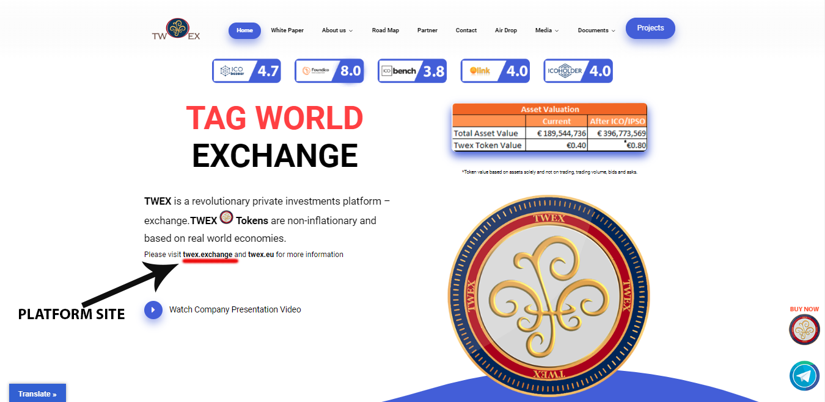

1. Directly visit our TWEX platform using www.twex.exchange.

To get registered on TWEX Exchange Platform follow the given steps in registration section.

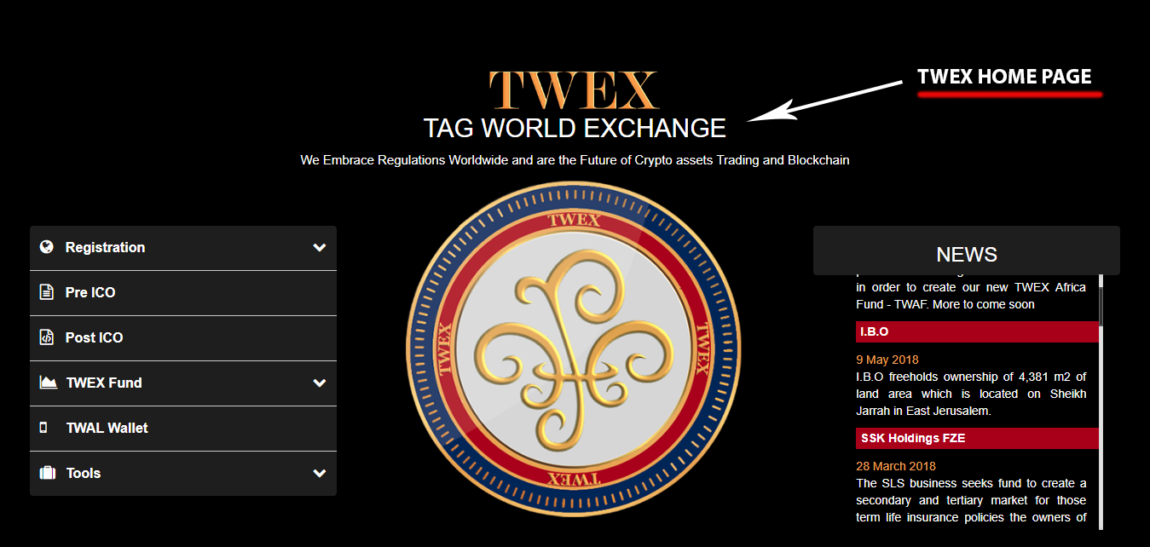

# **User Rights and Menu**

The TWEX platform menu is displayed based on the type of the user and user rights. Below is the user rights table based on which the menus are displayed: -



# **Basic Screens**

The application contains basic screens that can be seen as per the ***“User Rights and Menu section’’*** above

### **Home Screen**

Shows the following sections:-

1. Company Listed –
2. Symbols & Listing –
3. TWEX Funds –
4. Events –
5. News –

# **About Us Screen**

TWEX Limited is a UK Based company that was incorporated to run a smart contract trading.

As there are many platforms, many clients, many investors and two main common problem

1. Accuracy of information and fraudulent negation of responsibilities
2. And the age old problem of access to funds in case of dire need after making an investment we decided to offer investors the possibility to strip their investments, trade any parts of it via two smart contracts registered on the Blockchain community representing Capital and Profit payment(s).

We also offer to our investors our TWEX which are remitted to investors solely at the time of the ICO of the companies bundled together to form one group. Each Token holder thereof is entitled to one share of the funds collected every year. Said funds are paid by the companies that received the initial investments and are based on their sales.

Our Token – TWEX is limited to 400,000,000 at a par value of 0.40 Euro each.

Please consult our news section regularly for more information about these new TWEX TPS coming soon.

# **AML (Anti Money Laundering Policy) Screen**

It is the policy of the firm to prohibit and actively prevent money laundering and any activity that facilitates money laundering or the funding of terrorist or criminal activities by complying with all applicable requirements under the Bank Secrecy Act (BSA) and its implementing regulations.

Money laundering is generally defined as engaging in acts designed to conceal or disguise the true origins of criminally derived proceeds so that the proceeds appear to have derived from legitimate origins or constitute legitimate assets. Generally, money laundering occurs in three stages. Cash first enters the financial system at the "placement" stage, where the cash generated from criminal activities is converted into monetary instruments, such as money orders or traveler’s checks, or deposited into accounts at financial institutions. At the "layering" stage, the funds are transferred or moved into other accounts or other financial institutions to further separate the money from its criminal origin. At the "integration" stage, the funds are reintroduced into the economy and used to purchase legitimate assets or to fund other criminal activities or legitimate businesses.

Terrorist financing may not involve the proceeds of criminal conduct, but rather an attempt to conceal either the origin of the funds or their intended use, which could be for criminal purposes. Legitimate sources of funds are a key difference between terrorist financiers and traditional criminal organizations. In addition to charitable donations, legitimate sources include foreign government sponsors, business ownership and personal employment. Although the motivation differs between traditional money launderers and terrorist financiers, the actual methods used to fund terrorist operations can be the same as or similar to methods used by other criminals to launder funds. Funding for terrorist attacks does not always require large sums of money and the associated transactions may not be complex.

Our AML policies, procedures and internal controls are designed to ensure compliance with all applicable BSA regulations and FCA rules and will be reviewed and updated on a regular basis to ensure appropriate policies, procedures and internal controls are in place to account for both changes in regulations and changes in our business.

# **How to Buy (TWEX) Tokens Screen**

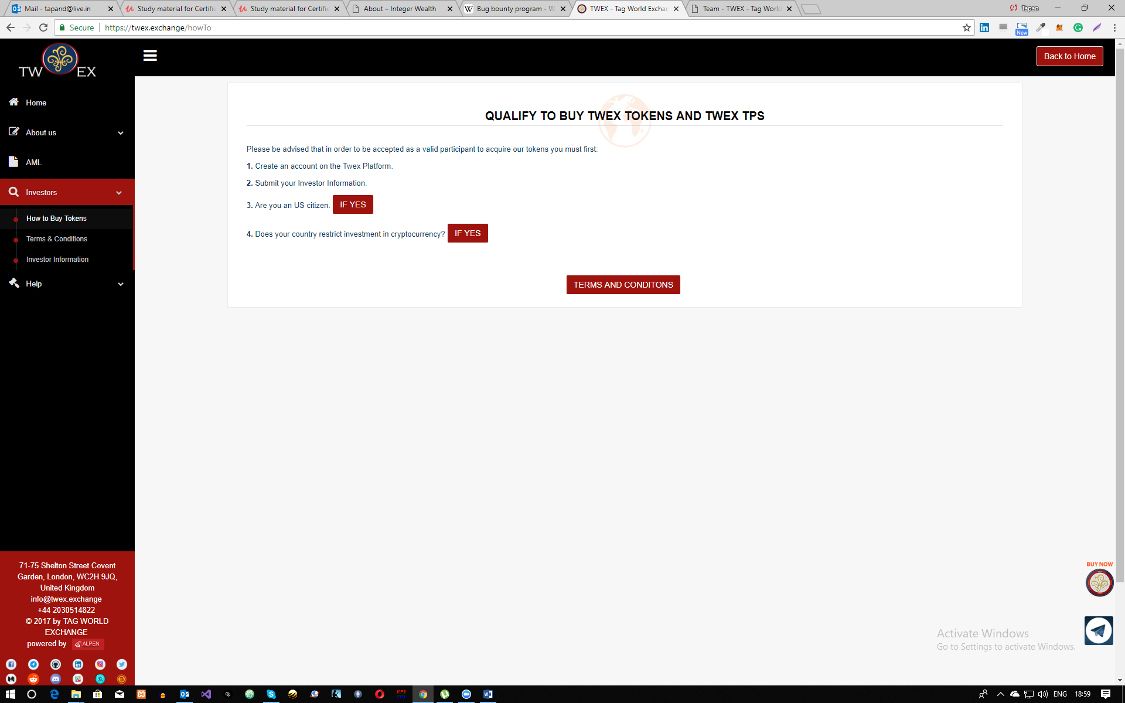

### **Help**

This section is provided to help users for getting detailed information about our Platform in the form of documents and videos.

In “**Help”** section there are two options available on the user menu provided on the left side of the screen.

* Documents
* Videos

#### Documents

In Document section you can find all documents related to our TWEX Platform. It includes two options i.e.

* System
* Marketing

**SYSTEM:** In system section you can find all documents related to our system

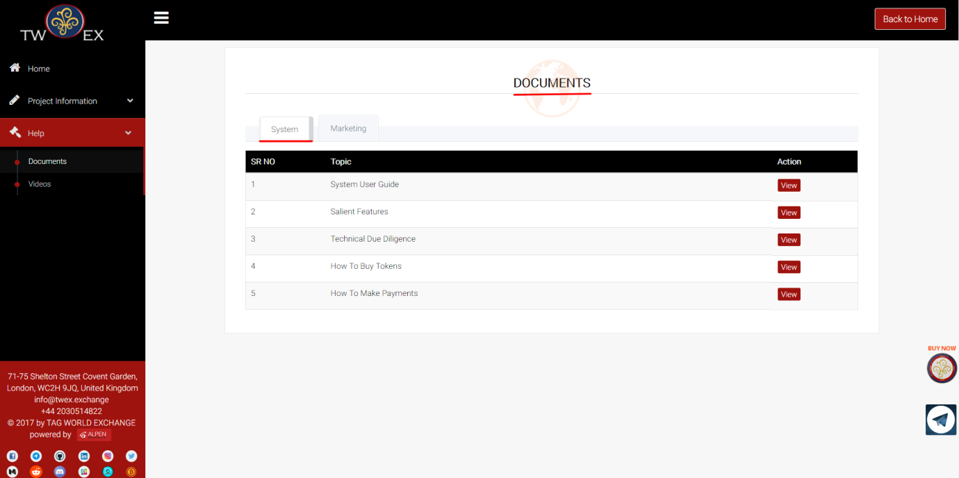

**Marketing:** In marketing section you can find all documents related to our TWEX marketing.

The following shows the list of marketing documents which are currently available on the screen.

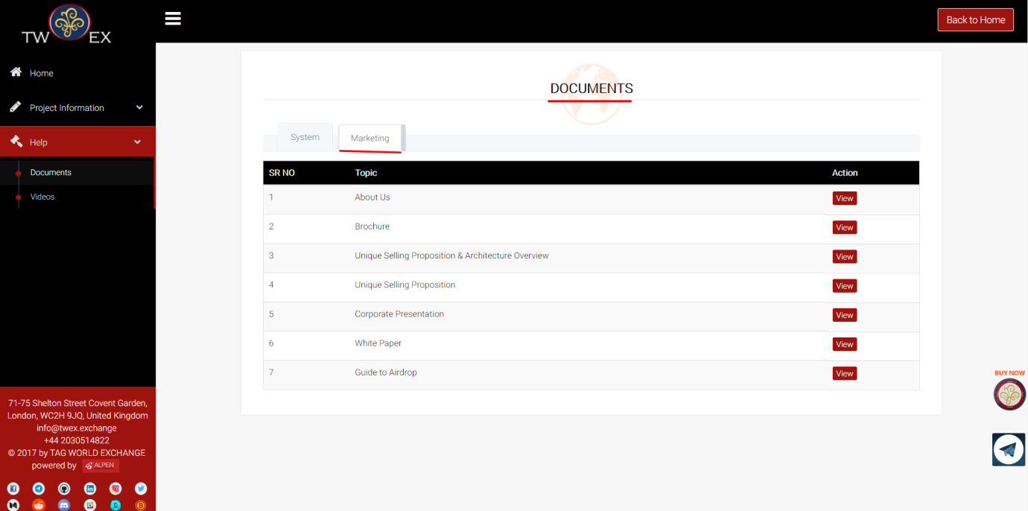

#### Videos

In the videos section you can find all the videos related to our TWEX Platform.

It includes two categories as mentioned below:

* System Information Videos
* Company videos

**System Information videos**: It provides guidance to the user regarding the investor registration form, company registration form and about trading.

**Company videos:** This section includes videos related to TWEX Platform.

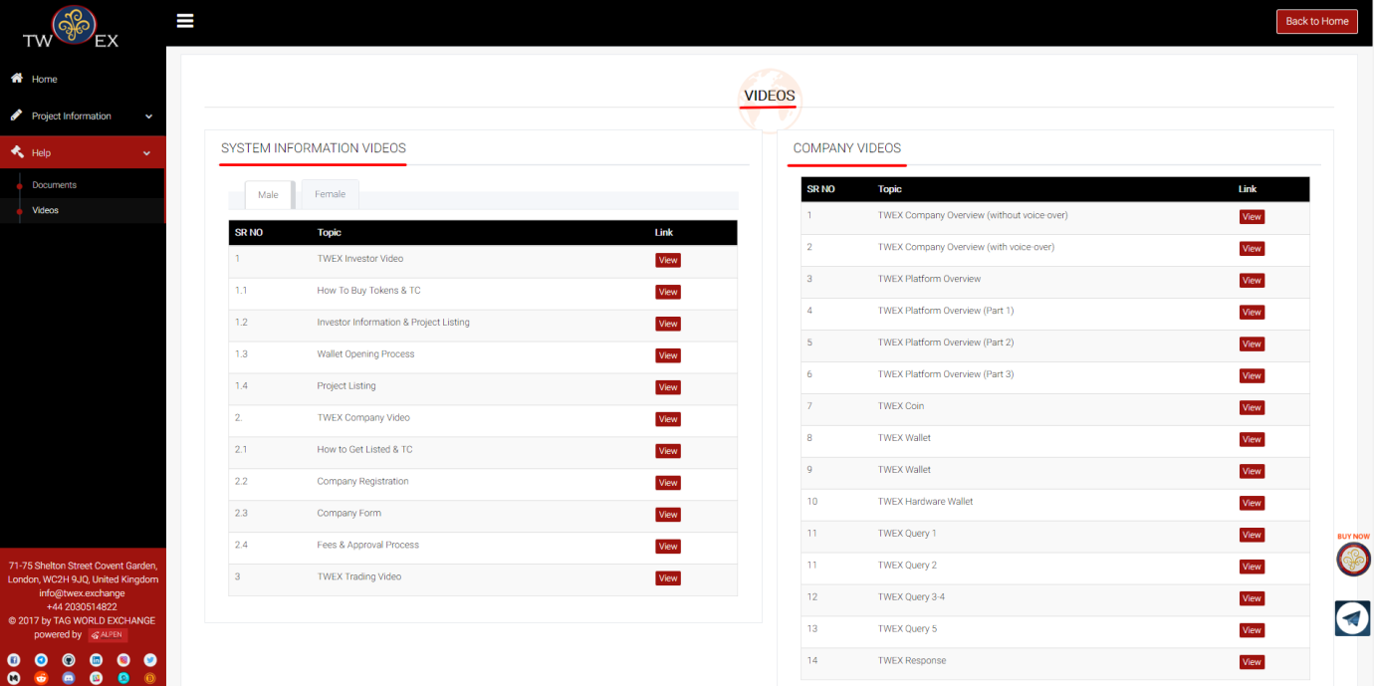

# **Registration**

To start using TWEX platform you need to register first using Registration form which is present under “Investor section”.

In Registration Section there are 3 options to get registered. One can enter as:-

* Visitor
* New User
* Existing User

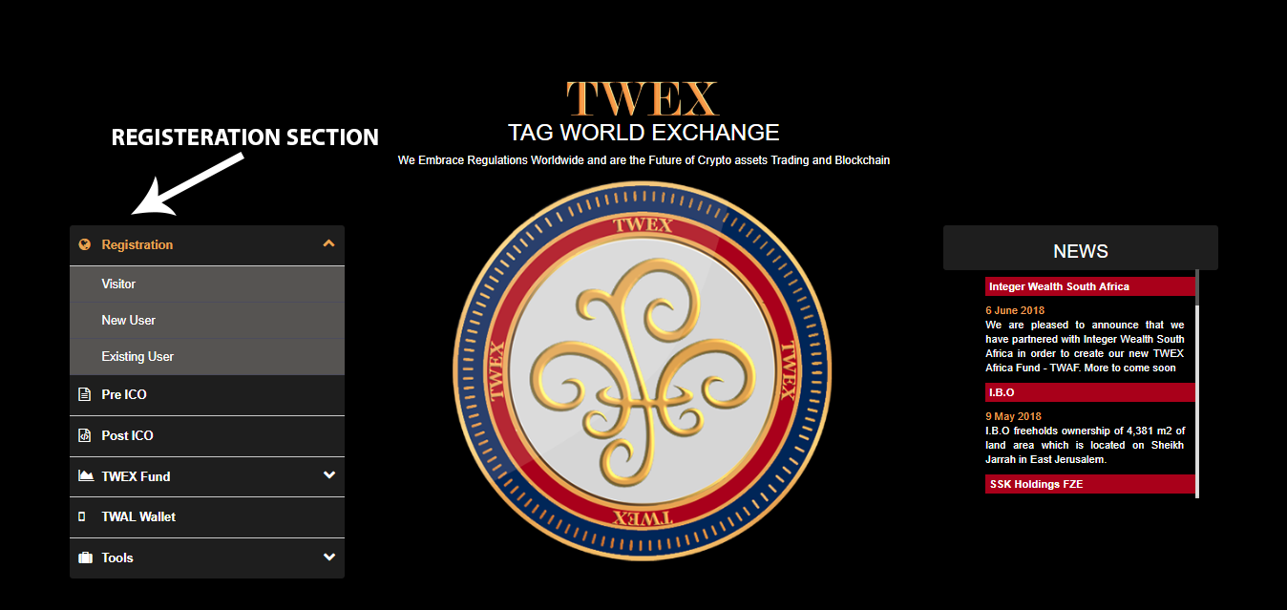

### *Visitor*

* 1. After clicking on visitor tab the page containing privacy policy will pop-up following an input field to enter your EMAIL ID

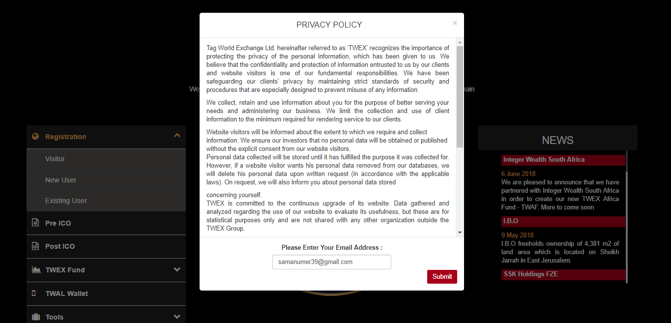

* 1. Enter your EMAIL ID to access TWEX platform as visitor and click on submit button to proceed further.

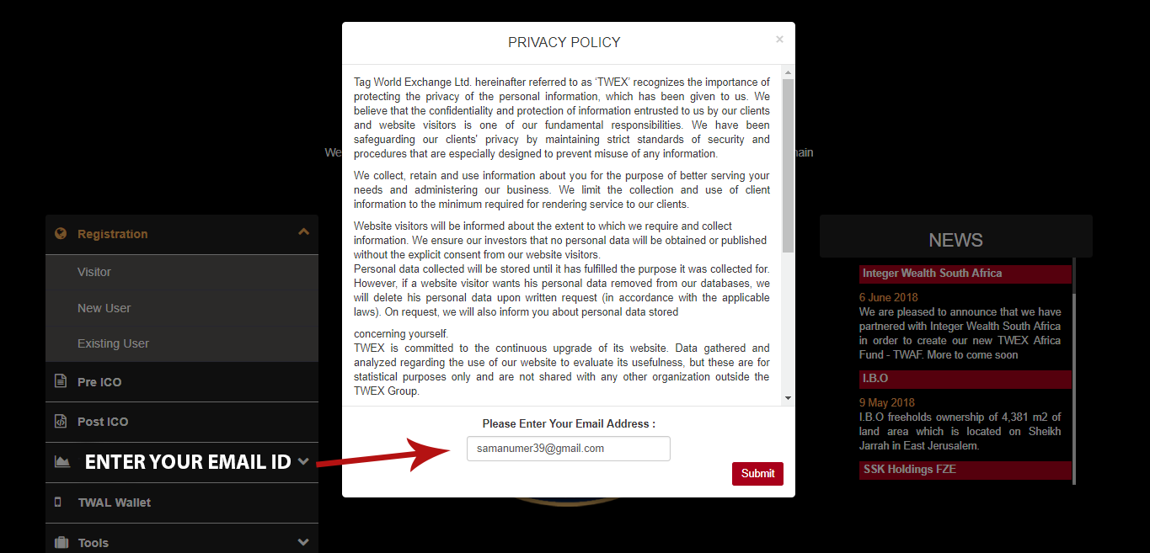

* 1. To proceed further click on OK button.

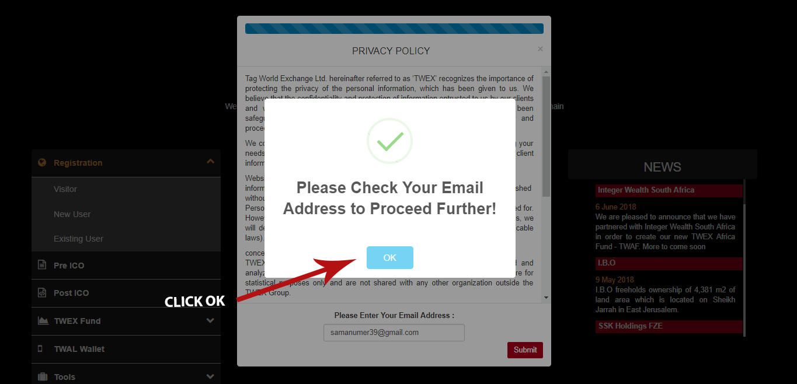

* 1. A confirmation mail would be sent to your registered email ID stating “**Thanks for registering on our platform**” and there will be a click here button that will take to you on visitor home page.

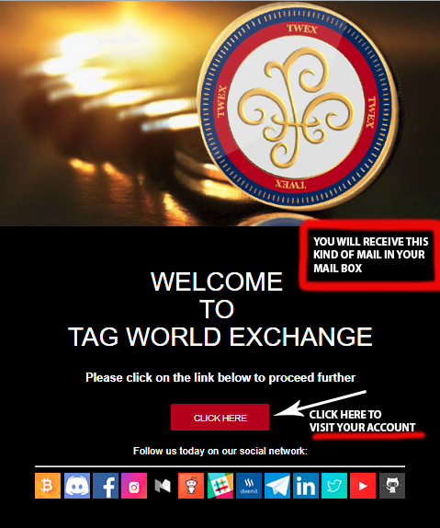

* 1. After clicking on verification link it will take you to this visitor home page.

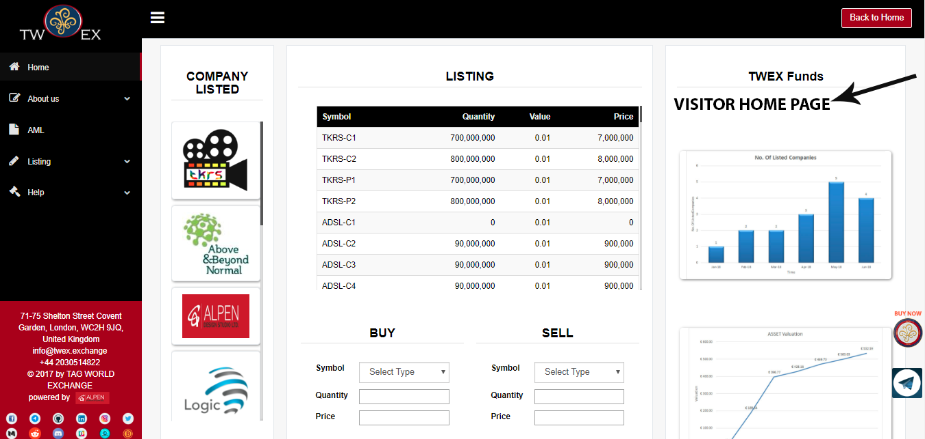

### *New User (Investor)*

1. If you are a new user, you have to register yourself by filling an investor information form that will be accessible by clicking on the new user option available on the start page which will take you to the Screen as below,

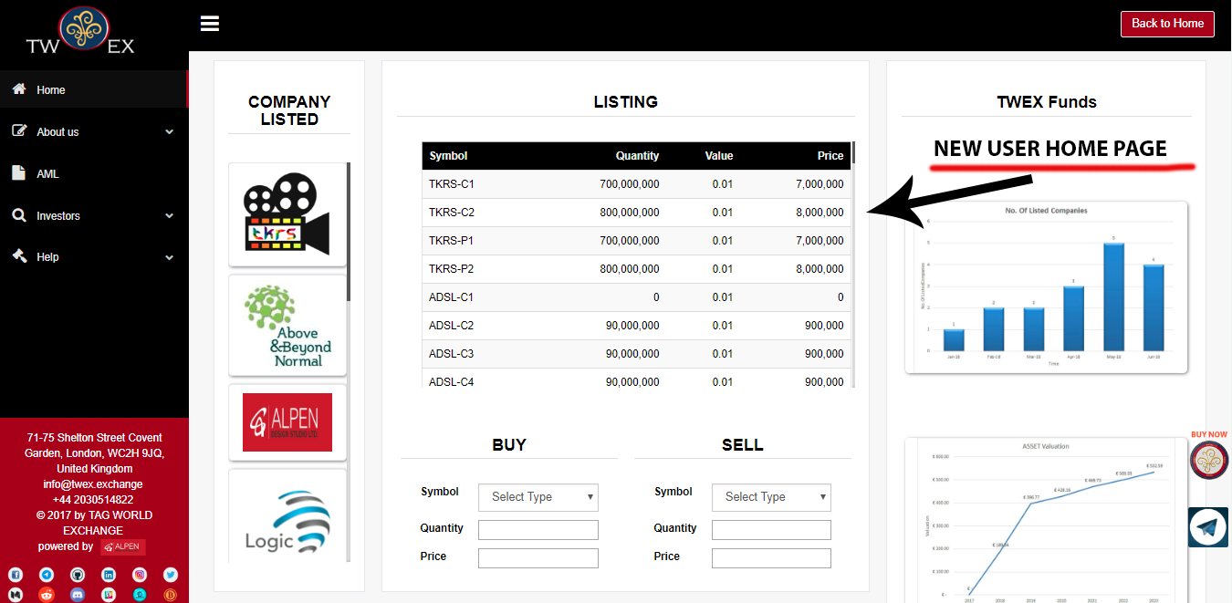

1. Click on Investor- Investor information Form will pop-up to fill your personal details.

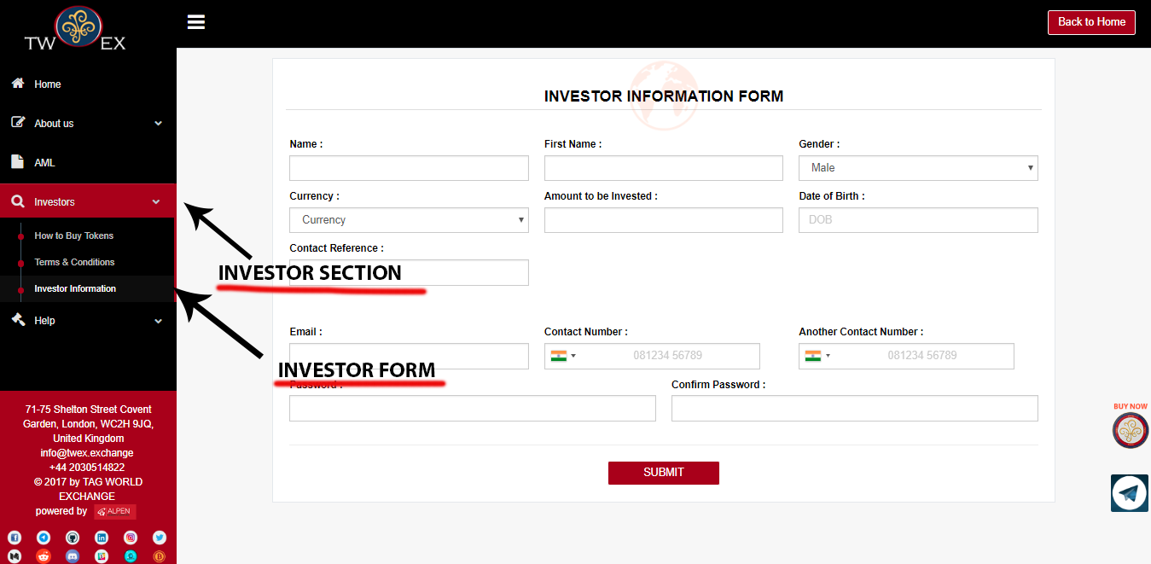



**Current Address & Corresponding Address Block**



1. After you have filled all your Personal data click on submit button.

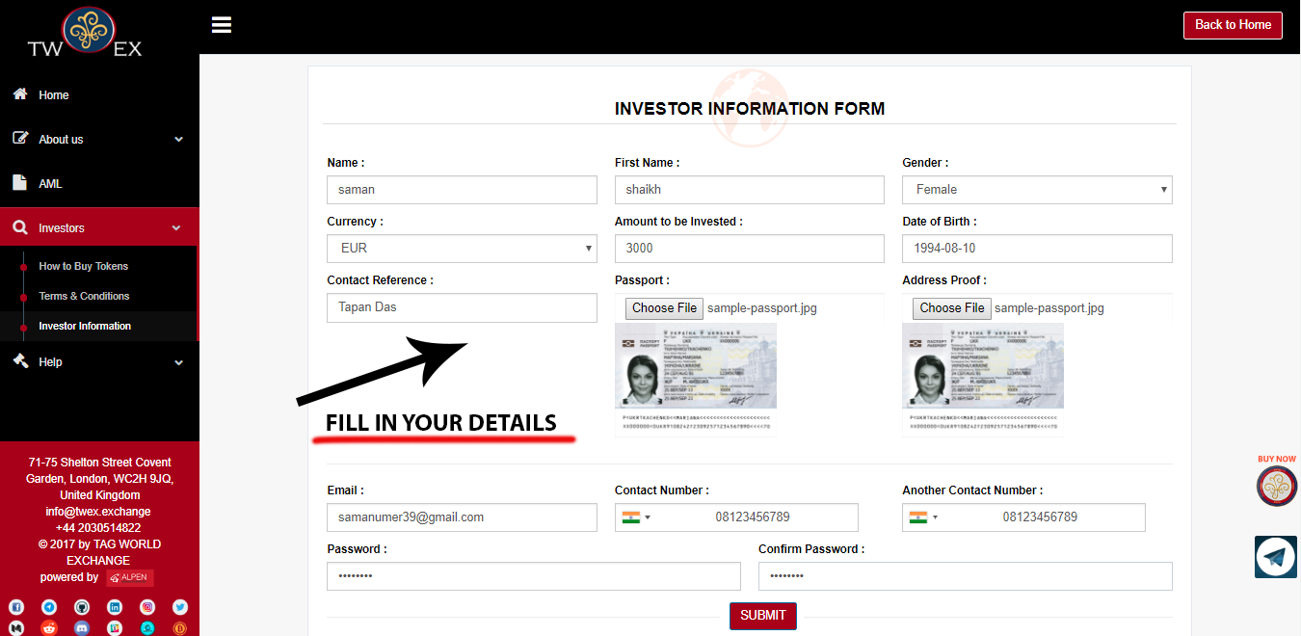

1. A verification mail would be sent to your registered email ID with a verification link. Clicking on which will lead you to a page with terms and conditions.

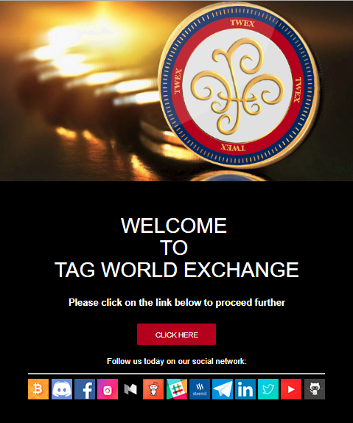

1. Read all Terms and condition and click on the “I Accept” check box after that click on the submit button to proceed further.

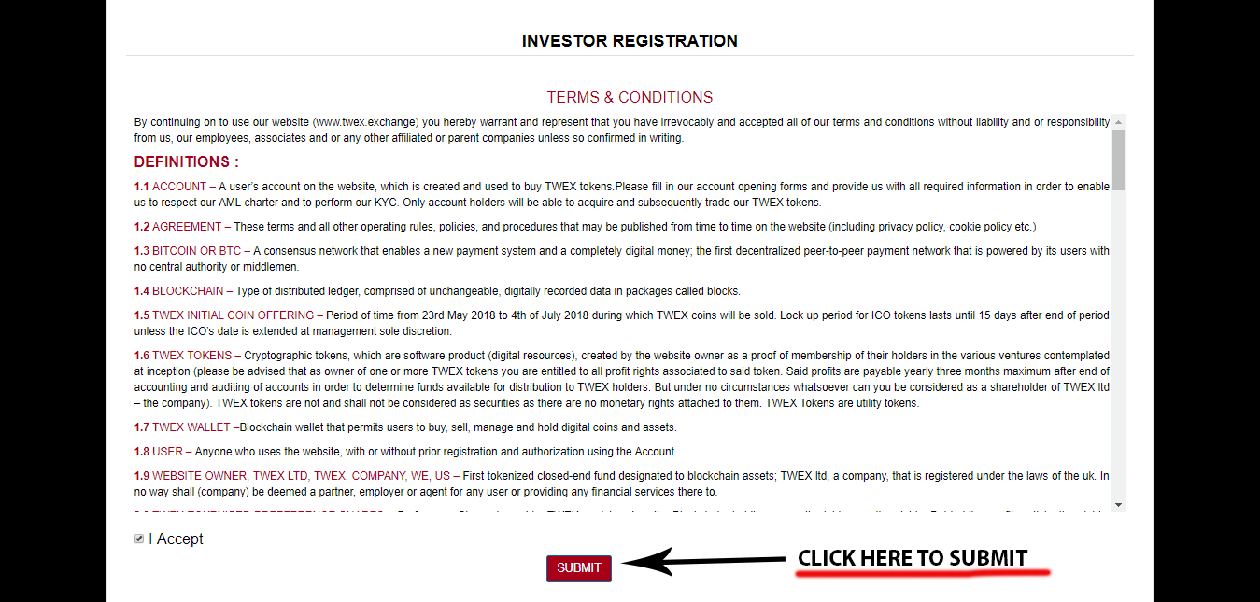

1. A mail containing your username and password will be sent to your registered email address. Using which you can now login into the system by clicking onto the “existing user option” available on the start page which will lead you to the login form.

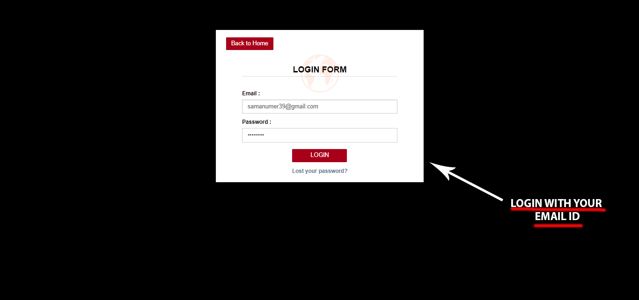

1. To Purchase TWEX token you need to open your Wallet first. Once you have logged in now you can open your own software wallet by clicking on the “**My Wallet – Wallet Opening Form**”.

# **Wallet Opening Form**

#### Step 1 – Basic Details

### 

The wallet opening form display’s investor (your) information on the screen that was filled up during the registration. The displayed items include

1. Account holder name
2. Date of Birth
3. Two Contact Numbers
4. Email Id
5. Current Address and Correspondence address
6. Additionally it shows two fields
7. TWEX Ether Address (non-editable).

Please note,

* TWEX Ethereum address: 0xd57411186C70BF13C81d7f999c9a3e775A3763E9.
* TWEX Bitcoin address: 1PHKZzqRihoyPVHApcZH8M4zKp4vM54pCq.
* TWEX Bitcoin Cash address: qrsm9c00l2uqrmet3y4z45dmycwrdhzkvsqe4cprsp.
* TWEX Bank Remittance Details: XXXXXX

Account Holder Ether Address which needs to be filled and updated by the Investor.

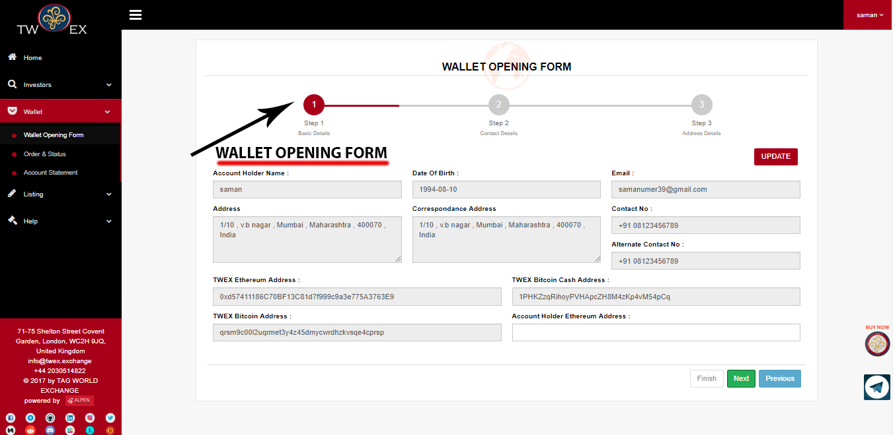

#### Step 2 – Contact Details

The second part of the form includes



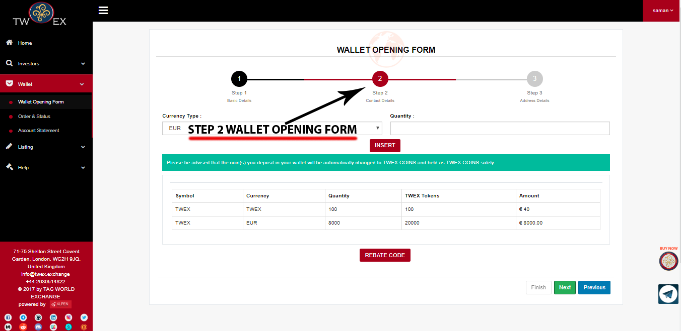

#### Step 3 – Address Details

The rebate code will be provided by your reference. If you don’t have one, don’t worry. You can still proceed opening your own wallet.

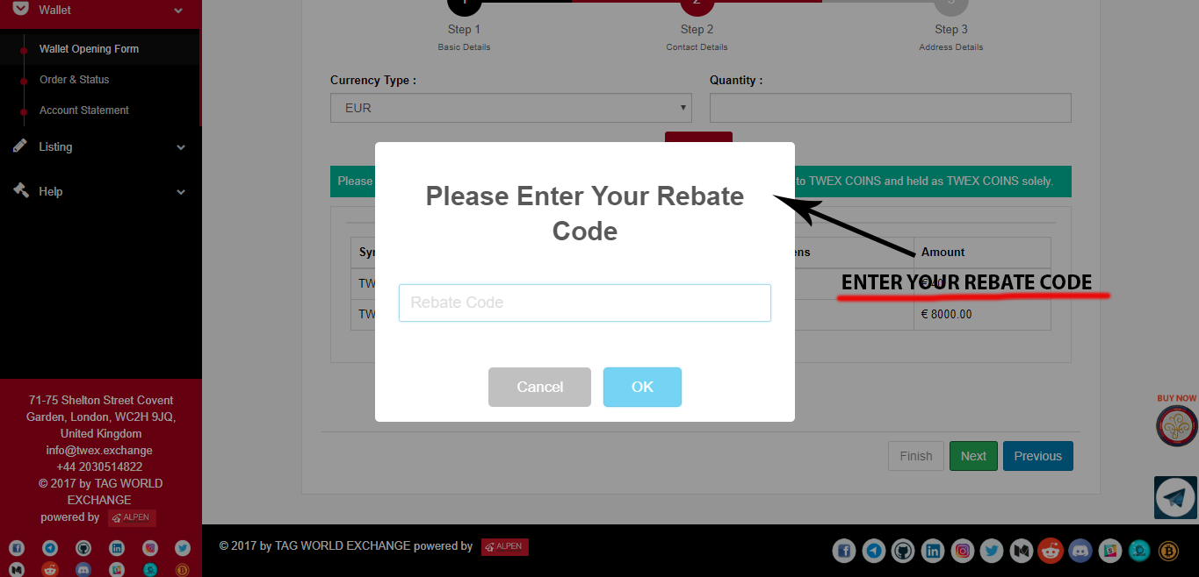

#### Step 4 – Open Wallet

Once you have selected the Wallet Type you are good to go and open your own wallet at real time by pressing the “Open Wallet” button.

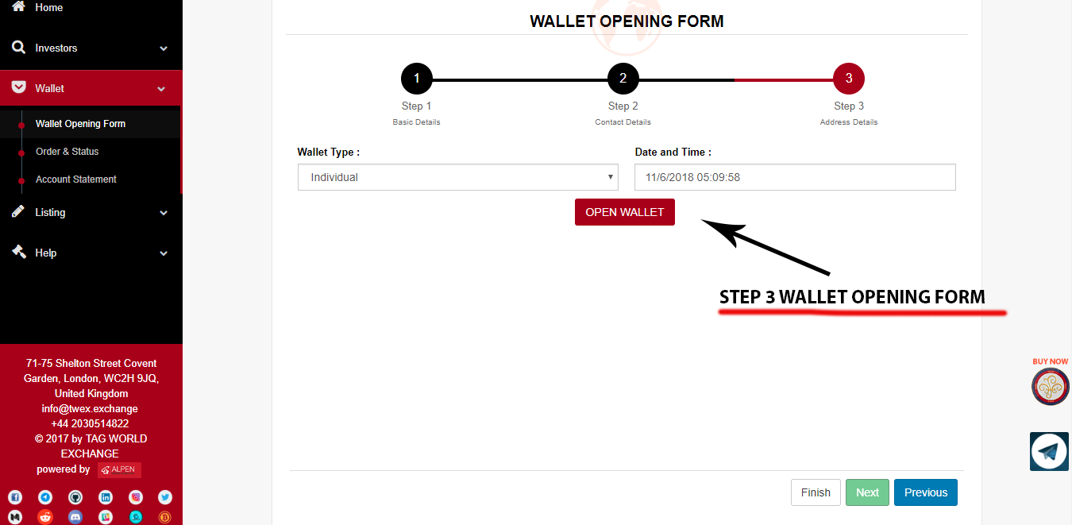

#### Step 5 - Confirmation

It would take you to the last step “Are you sure? You want to proceed further” Click on “Ok” button.

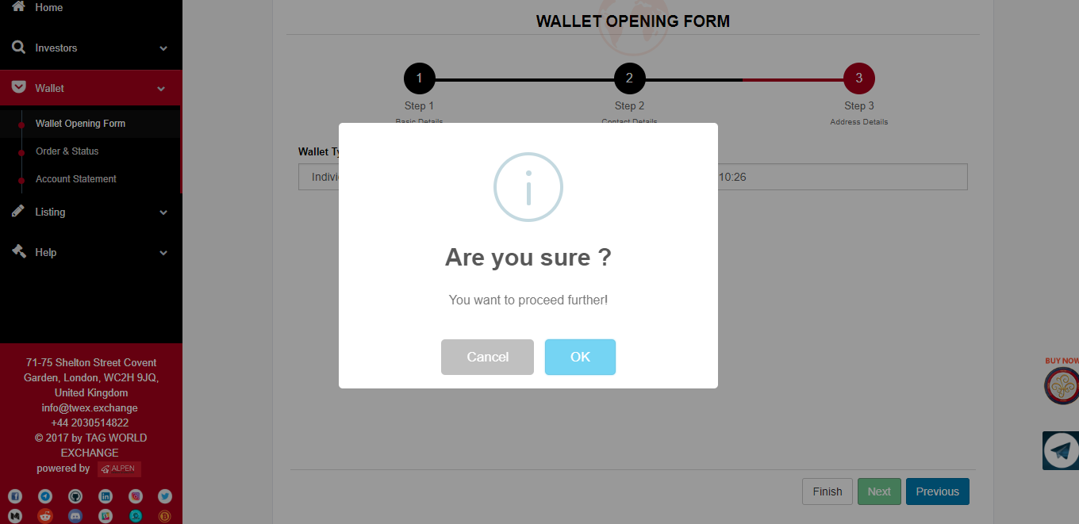

And would display that your “Wallet Opened Successfully!”

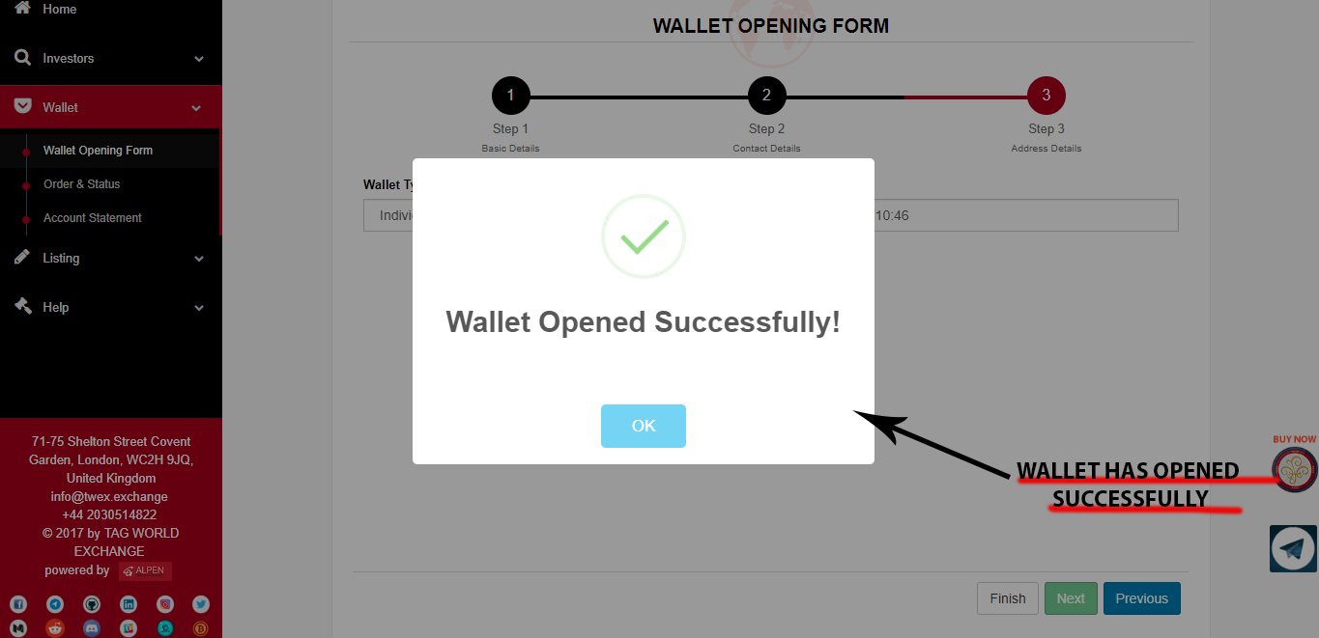

### *Existing User*

1. If you are an existing user so you can click on existing user tab that will lead you to the login form page.

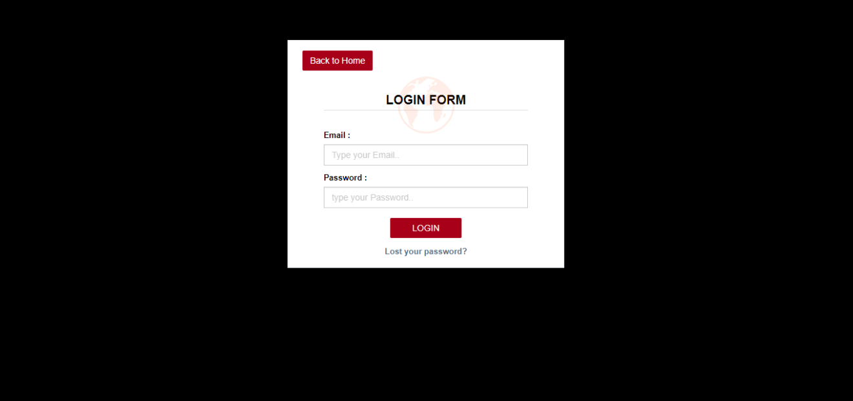

1. Once the user is logged in then following screen appears.

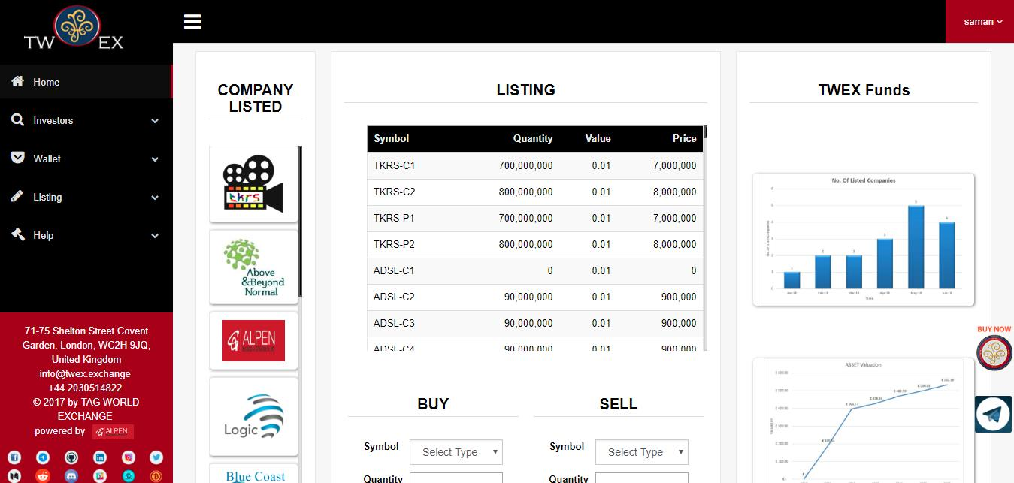

1. If wallet is already opened and if user wishes to add some more orders in their wallet then user can click on order and status option which is present under wallet section.
2. **Execute order**

* You have to select transaction type and currency type, then click on the button “BUY NOW” you will see your data in the following table.

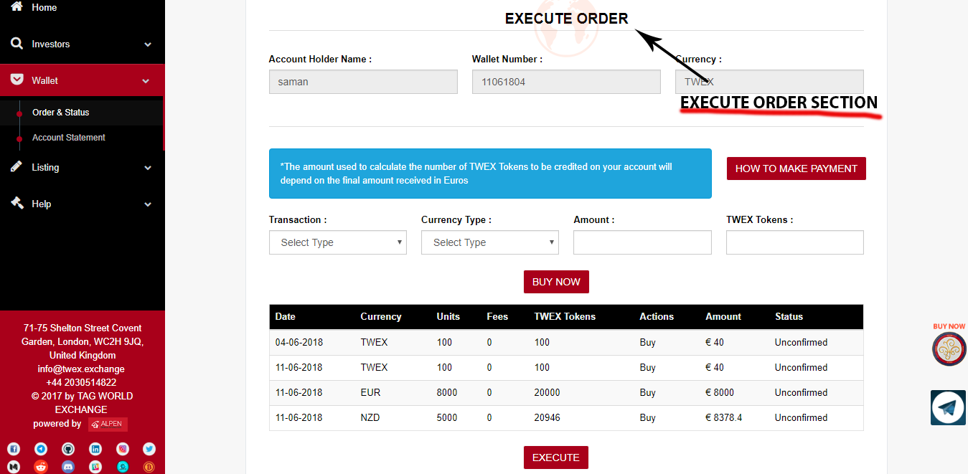

* In order to “EXECUTE” your order you need to press “EXECUTE” button after which that order execution will be completed. Click on “EXECUTE”, you will get a Pop-up stating “**Are you sure want to proceed further?”**

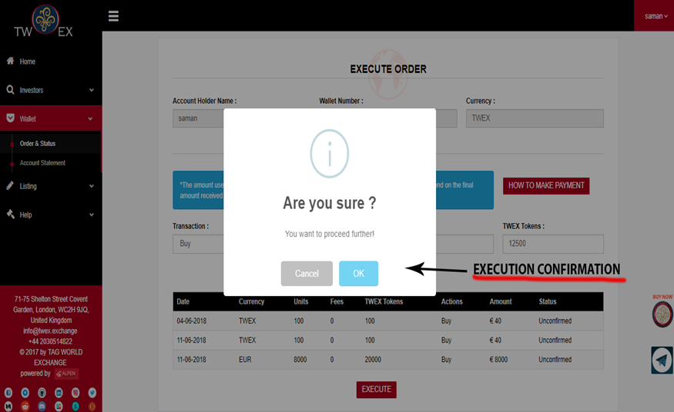

* On OK it will show **“Successfully Executed”** message box.

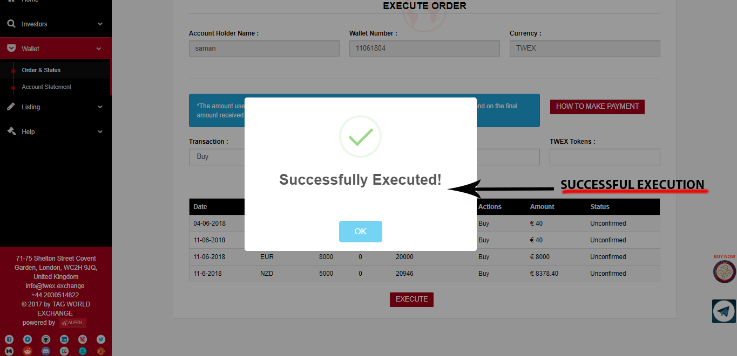

* To Proceed with Payment click on “How to make payment” button after which a page with all payment instruction will be available in front of you, following that instruction there will be a “MAKE PAYMENT” button which will redirect you to payment page.

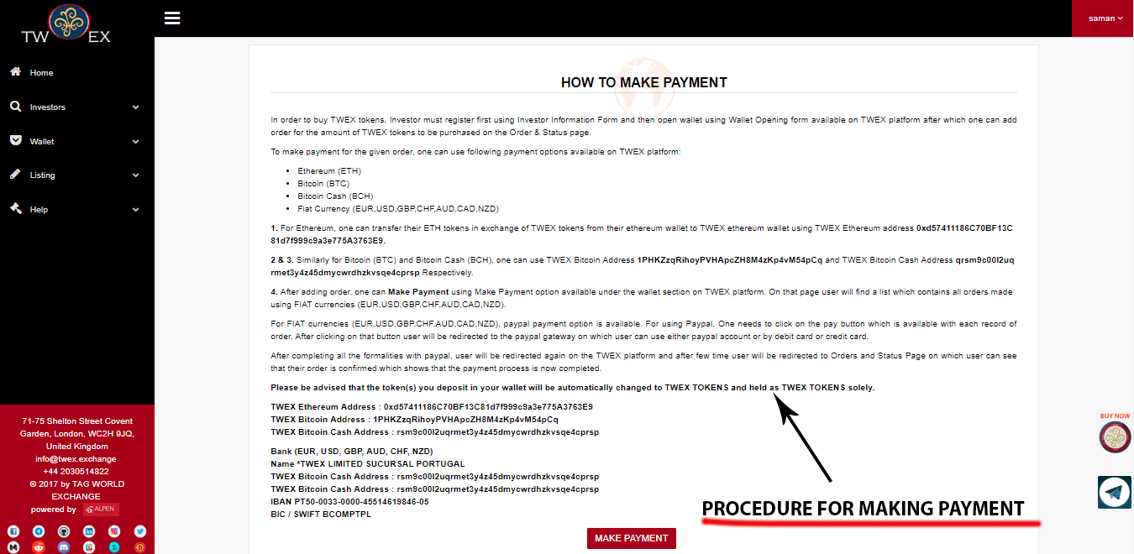

* Select the Payment Option – There are 4 Options available
  + 1. PayPal
    2. ETH
    3. BTC
    4. BCH

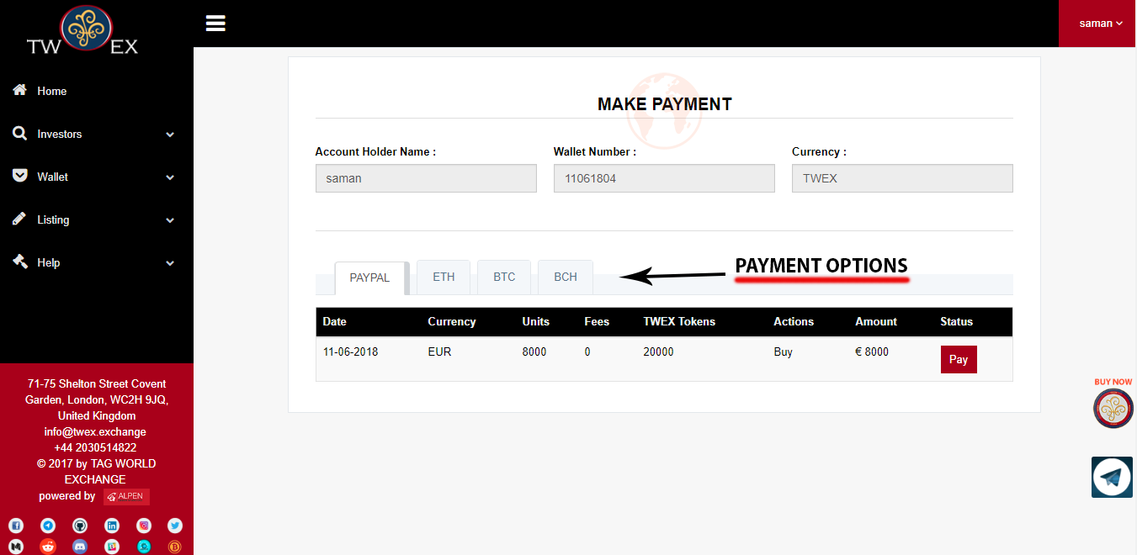

* PayPal – If you wish to proceed with payment using fiat currency than you can use PayPal option in PayPal option there are 2 choices available currently,
  + 1. Using your PayPal account
    2. By using your Credit and Debit card.

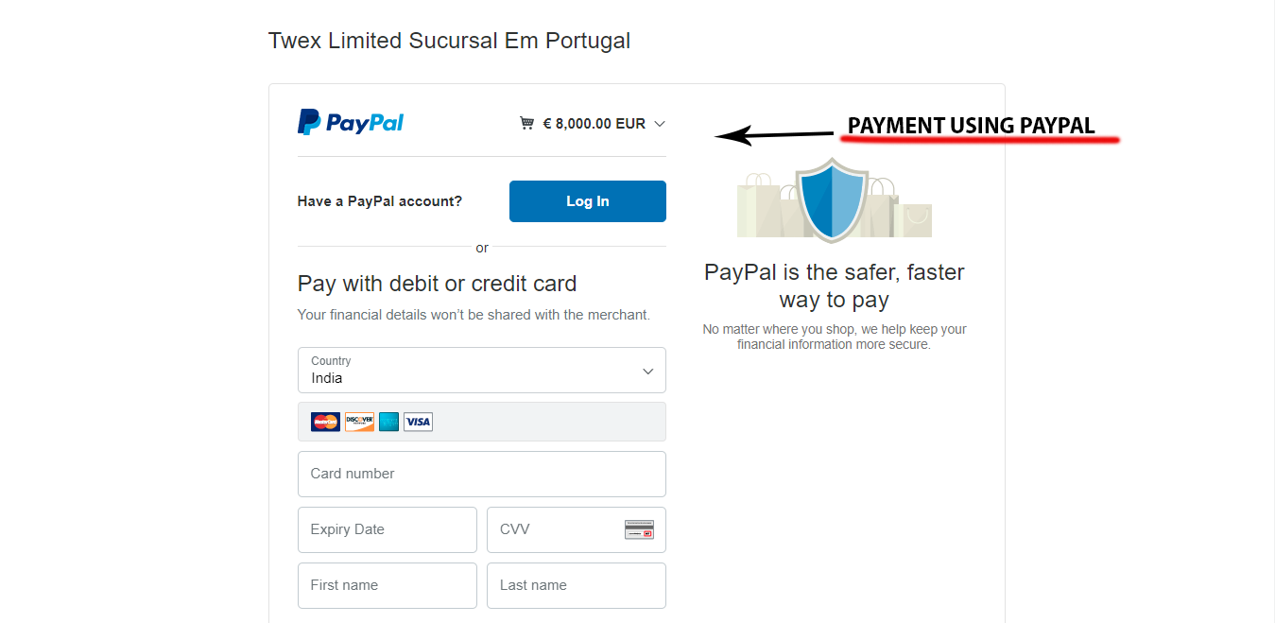

* ETH, BTC, BCH - For Eth you have to scan QR code.

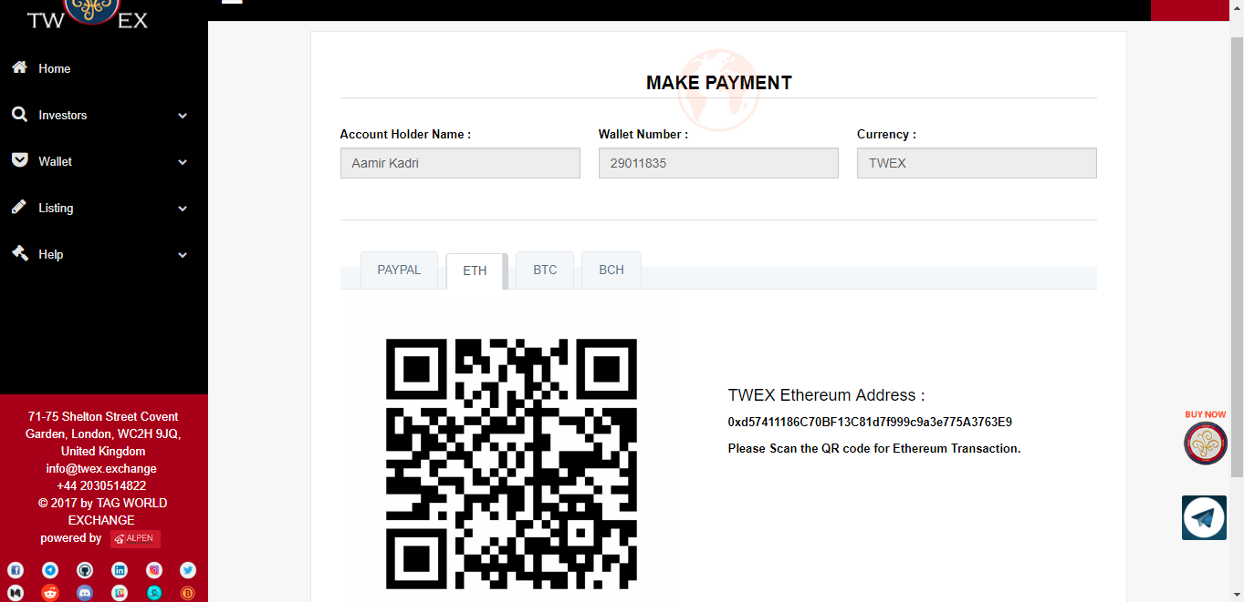

1. **Account Statement section**

The number of TWEX tokens Debit, Credit and status will be shown.

*Status:*

* Confirmed – If your transaction is complete it will show confirm.
* Unconfirmed- If your transaction is incomplete it will show unconfirmed.

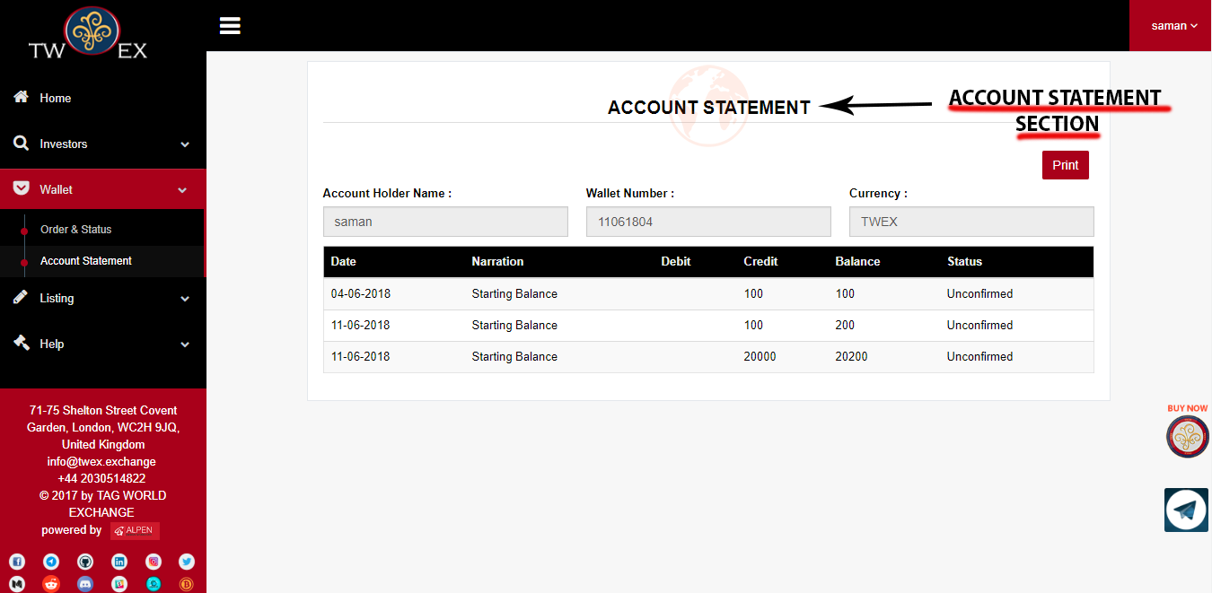

# **PRE-ICO SERVICES**

**If you are in PRE-ICO phase and your company is listed on some other platform and you are finding difficulty regarding security of your token then you can take benefit of TWEX platform using our PRE-ICO services.**

### ***What We Can Do For You***

You have a fantastic new revolutionary idea based in the blockchain and have heard that the best way to implement it and fund it is via an ICO. Whereas you might have some ideas of how to carry your plans to fruition, you might not have all the ins and outs and maybe not the time to take care of all the required documentation and actions that will set you apart and dissociate you from all the scam ICOS out there.

We at TWEX can help you.

1. We will review jointly with you your plans and goals,
2. Ascertain your means to implement same,
3. Create a plan of action that will be implemented as soon as you are ready to start,
4. Help you open a bank account in order to also accept FIAT currencies once you start your ICO,
5. Create a functional website to portray your product and invention,
6. Prepare your whitepaper and sales prospectus according to US, UK, EU and Indian Laws irrespective of your country of residence and or incorporation,
7. Create our proprietary Tokenized Preferred Share for your company,
8. List your TPS on our Exchange with a direct exchangeability of 1 TPS for 1 native Token both traded at exactly the same price,
9. Creation of your ERC-20 tokens,
10. Introduce your project to our 10,000+ email listing

Then you have to market your ICO. We can help you to do so but there are additional costs to that.

### ***TPS or Tokenized Preferred Share***

You must have seen all of these articles in Coin Telegraph, Coin base and the likes about the SEC’s push to regulate ICOs and classify all of them as security tokens.

### ***Premises***

No matter how big you are or even how rich you are, doing an IPO is very costly – only for compliance you must spend at least 250,000 USD per year with at least one full time employee devoted to that task. This does not take into consideration all other factors pertaining to the size of your company and to the recorded sales accompanied by insured audits made by a select few group of auditors that will charge you a lot for their services. These tenuous requirements that came into force after 9/11, Enron and all the other ensuing scandals leading to the 2008 collapse were designed to protect investors’ funds so that never again the same things could happen!.

Then came the introduction of ICOS. A techie has an idea but no money to do it. He writes a White paper (condensed version of a prospectus almost without risk factors), prepare a nice funky website and group some friends and family to raise between 200 to 500,000 Dollars and then start a marketing campaign where he asks various categories of people to invest in the next ‘Bitcoint’! He promises to use their money and do some wonderful technical feat that needs consensus and that is decentralized and based on the blockchain (the magic words). In other words: give me your money and then in one to two years’ time.

If all goes well I will perform! Believe in me… Many of them raised Millions upon millions of Dollars from investors who did not want to miss out on the next ‘Bitcoin’ and invested small amounts of money just to see. Once the funds were raised they suddenly realized that they did not owe anything to anybody as the funds were paid in ETH and BTC to private and anonymous crypto accounts. Many of them decided to move to the Bahamas and to Rio…

In comes the SEC and rightly so, wanting to regulate and protect investors who are being taken to the cleaners. Said investors cannot even come together and file a class action lawsuit as more often than not the defrauders have disappeared in a cloud of anonymity and secrecy never to be found or heard of again.

For the SEC, this new state of affairs is bad as they do not know from what end to approach the entire situation not comprehending at all Blockchain, crypto, etc. The only way left to do their job protecting the American investors is to regulate and stop the savage ICOS taking place in the hundreds every day the World over. The easiest way to regulate is to classify all ICOS as security tokens: do you have a market value? (YES) Can the value appreciate and or fluctuate? (YES) Then you are a security token as people can make profits while trading your token.

This simple approach alleviates a series of problems for the SEC ranging from how to regulate, what to regulate, what is and what is not a security or utility token.

Classify all ICOS as securities, obligate KYC, AML and risk disclosures, and force sale to accredited investors only and voila: you have a new class of security that when traded and having generated capital gains will be taxed at 30 %! Quite the perfect outcome: no more manpower required, business as usual, protection of investors and tax collection!

Now when such rules are in place most of the Exchanges as they exist presently will cease to exist as they will not be allowed to trade securities unless they are licensed to trade securities and to act as an Exchange! Needless to say many will not qualify and investors the world over will have problems converting their coins in cash! A series of lawsuits can be expected for these investors who will lose money this way and not be able to sell their coins.

Most of the companies having run an ICO will have to reclassify as securities and take all actions as if they were publicly listed and 90 % of them will fail. There will no longer be any more ICOS for a majority of these companies.

Many of them upon listening to that for some and as a principle against US Federal Laws for others will tell you that there is a simple solution: restrict the ICO and refuse to sell to Americans. By the way they are already restricted to sell to Chinese, Japanese, South Koreans, and Singaporeans (all of which are big crypto markets).

What do you think the FCA is going to do when they hear about the SEC’S new set of rules? What do you think the ECB, BAFIN, etc. will do? All of them will follow suit as these new set of rules are simple to follow and to implement as it is business as usual and makes sense for them.

Then when all these Jurisdictions start following suit and enforcing the same type of rules where are you going to sell? Only Africa, South and Central America and Mongolia will be left… So in other words all of these people are going to fight for what little money that can be raised in these countries!

Needless to say that the success rate of ICOs will be even lower

We at TWEX have created a new revolutionary way to tackle all these coming problems: Do your ICO as usual for now, but use our services immediately to prepare for the future!

In order to do so we ask of you to issue a Preferred Share by your company that will be backed by your corporate assets and hold a prime rank in case of bankruptcy. These Preferred Shares are going to be tokenized by us and linked to your Token in order to hold the same value. The TPS (Tokenized Preferred Share) will be exchangeable one for one and cannot exceed the total number of tokens issued. The day regulations come in internationally and you can no longer trade your tokens, your convert to TPS and continue.

Can anybody forbid you from borrowing money? The only limitation you have is whether the lender accepts your collateral and is satisfied by your capacity to service the debt. Can any government, even a communist one, forbid you from borrowing money? No – it is purely between you and your lender. These are the premises of the TPS referencing regulations and others.

A direct one to one correlation of price and indexation of value, with the sole difference that, the Token is sold with the TPS. The TPS will hold all the monetary rights while the Token can be the true utility token it was supposed to be or purported to be!

# **Company Registration Form - Pre-ICO Services**

### 

#### **STEP 1 – Basic Details**

In Pre-ICO services, first the companies have to fill the company registration form, under which it requires the registrar’s company details, project details, fundraising, its income etc.

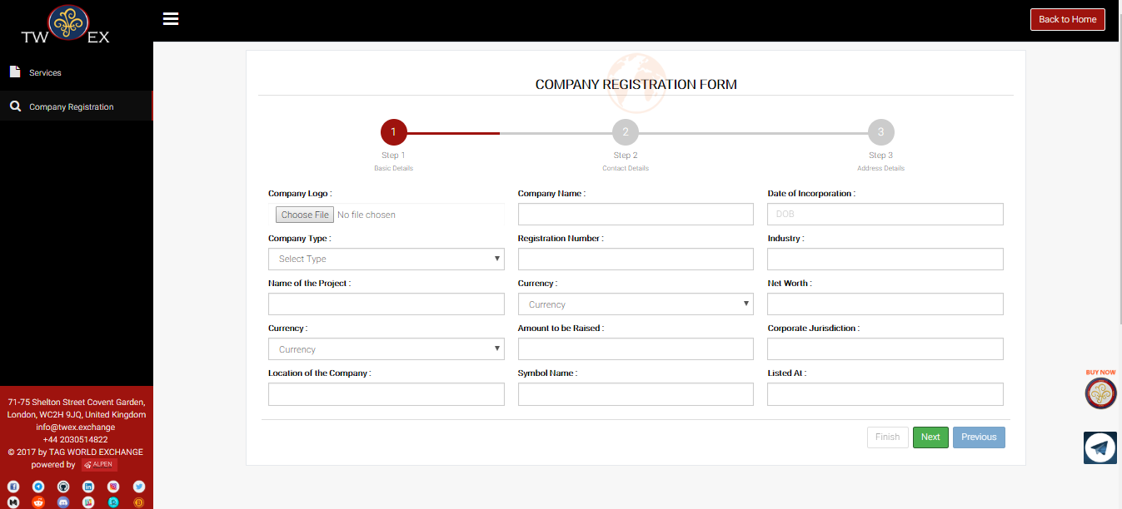

#### **STEP 2 – Contact Details**

In pre-ICO services **step 2** consists of the contact details of the company which requires the email-id, website, contact number and also another contact number (i.e. reference number) of the registrar or the companies getting registered.

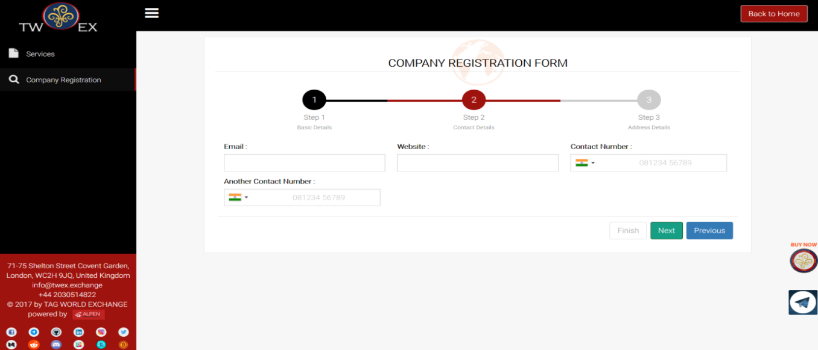

#### **STEP 3 – Address Details**

**3rd step** of Pre-ICO services consists of address details of the registrar’s/ companies who have registered and as well as their correspondence address.

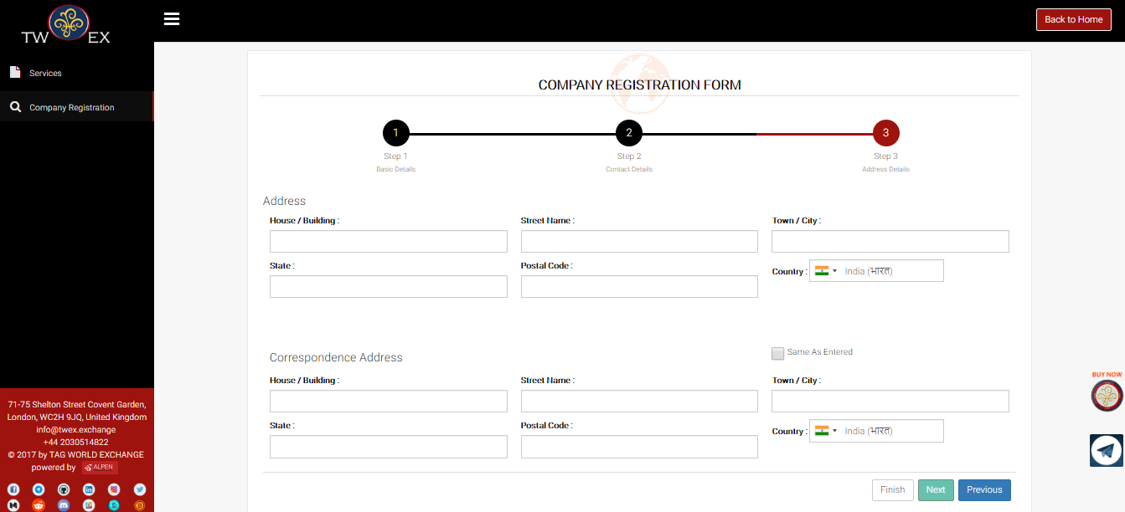

#### **STEP 4 – Confirmation**

After you have filled all your details click on finish button, you will get a Pop-up stating “**Are you sure want to proceed further?” then press OK button to proceed further.**

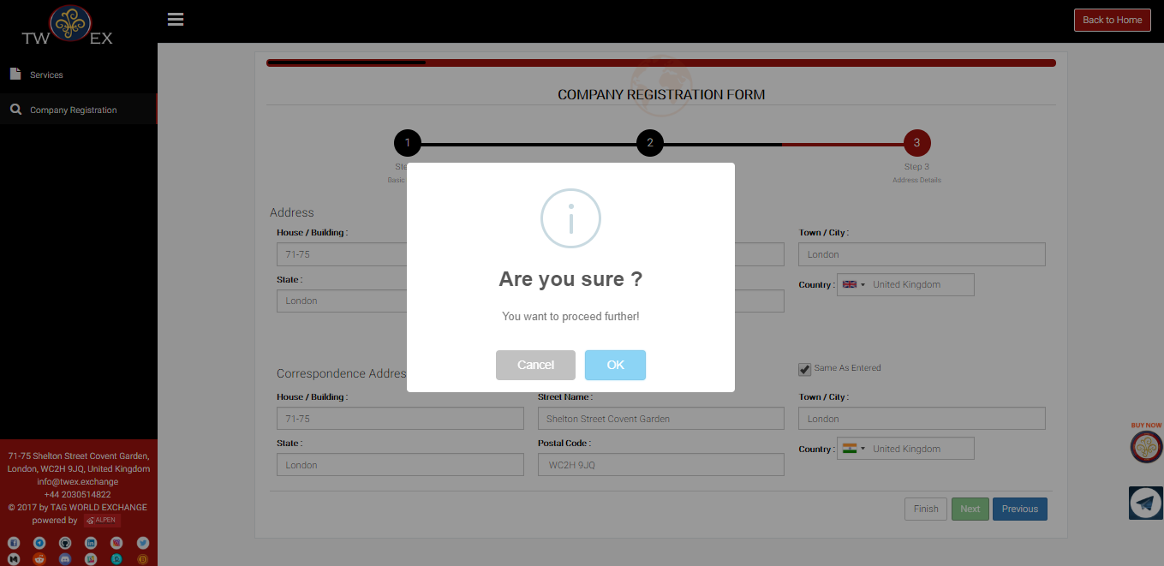

#### **STEP 5 – Completion**

After clicking OK, A message stating **"Thank you for completing Company Registration!"** will appear which means that registration process for your company is completed. After Registration, your request will be sent to legal and board for approval after which your company will be listed on TWEX platform.

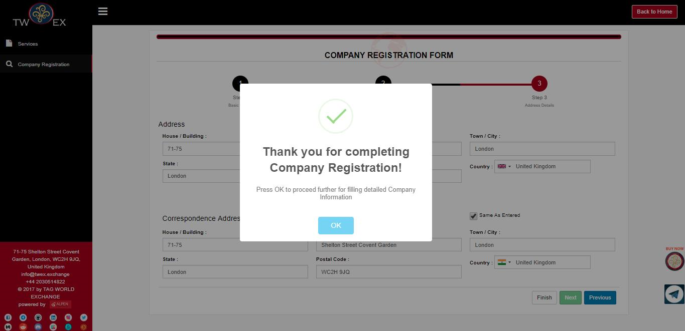

# **POST-ICO SERVICES**

**If you are in Post-ICO phase and your company is listed on some other platform and you are finding difficulty regarding security of your token then you can take benefit of TWEX platform using our Post-ICO services.**

### ***What We Can Do For You***

You have a fantastic new revolutionary idea based in the blockchain and have heard that the best way to implement it and fund it is via an ICO. Whereas you might have some ideas of how to carry your plans to fruition, you might not have all the ins and outs and maybe not the time to take care of all the required documentation and actions that will set you apart and dissociate you from all the scam ICOS out there.

## 

**We at TWEX can help you.**

1. We will review jointly with you your plans and goals,
2. Ascertain your means to implement same,
3. Create a plan of action that will be implemented as soon as you are ready to start,
4. Help you open a bank account in order to also accept FIAT currencies once you start your ICO,
5. Create a functional website to portray your product and invention,
6. Prepare your whitepaper and sales prospectus according to US, UK, EU and Indian Laws irrespective of your country of residence and or incorporation,
7. Create our proprietary Tokenized Preferred Share for your company,
8. List your TPS on our Exchange with a direct exchangeability of 1 TPS for 1 native Token both traded at exactly the same price,
9. Creation of your ERC-20 tokens,
10. Introduce your project to our 10,000+ email listing

Then you have to market your ICO. We can help you to do so but there are additional costs to that.

### ***TPS or Tokenized Preferred Share***

You must have seen all of these articles in Coin Telegraph, Coin base and the likes about the SEC’s push to regulate ICOs and classify all of them as security tokens.

### ***Premises***

No matter how big you are or even how rich you are, doing an IPO is very costly – only for compliance you must spend at least 250,000 USD per year with at least one full time employee devoted to that task. This does not take into consideration all other factors pertaining to the size of your company and to the recorded sales accompanied by insured audits made by a select few group of auditors that will charge you a lot for their services. These tenuous requirements that came into force after 9/11, Enron and all the other ensuing scandals leading to the 2008 collapse were designed to protect investors’ funds so that never again the same things could happen!.

Then came ICO’S. A techie has an idea but no money to do it. He writes a White paper (condensed version of a prospectus almost without risk factors), prepare a nice funky website and group some friends and family to raise between 200 to 500,000 Dollars and then start a marketing campaign where he asks various categories of people to invest in the next ‘Bitcoin’! He promises to use their money and do some wonderful technical feat that needs consensus and that is decentralized and based on the blockchain (the magic words). In other words: give me your money and then in one to two years’ time

If all goes well I will perform! Believe in me… Many of them raised Millions upon millions of Dollars from investors who did not want to miss out on the next ‘Bitcoin’ and invested small amounts of money just to see. Once the funds were raised they suddenly realized that they did not owe anything to anybody as the funds were paid in ETH and BTC to private and anonymous crypto accounts. Many of them decided to move to the Bahamas and to Rio…

In comes the SEC and rightly so, wanting to regulate and protect investors who are being taken to the cleaners. Said investors cannot even come together and file a class action lawsuit as more often than not the defrauders have disappeared in a cloud of anonymity and secrecy never to be found or heard of again.

For the SEC, this new state of affairs is bad as they do not know from what end to approach the entire situation not comprehending at all Blockchain, crypto, etc. The only way left to do their job protecting the American investors is to regulate and stop the savage ICOS taking place in the hundreds every day the World over. The easiest way to regulate is to classify all ICOS as security tokens: do you have a market value? (YES) Can the value appreciate and or fluctuate? (YES) Then you are a security token as people can make profits while trading your token.

This simple approach alleviates a series of problems for the SEC ranging from how to regulate, what to regulate, what is and what is not a security or utility token.

Classify all ICOS as securities, obligate KYC, AML and risk disclosures, force sale to accredited investors only and voila: you have a new class of security that when traded and having generated capital gains will be taxed at 30 %! Quite the perfect outcome: no more manpower required, business as usual, protection of investors and tax collection!

Now when such rules are in place most of the Exchanges as they exist presently will cease to exist as they will not be allowed to trade securities unless they are licensed to trade securities and to act as an Exchange! Needless to say many will not qualify and investors the world over will have problems converting their coins in cash! A series of lawsuits can be expected for these investors who will lose money this way and not be able to sell their coins.

Most of the companies having run an ICO will have to reclassify as securities and take all actions as if they were publicly listed and 90 % of them will fail. There will no longer be any more ICOS for a majority of these companies.

Many of them upon listening to that for some and as a principle against US Federal Laws for others will tell you that there is a simple solution: restrict the ICO and refuse to sell to Americans. By the way they are already restricted to sell to Chinese, Japanese, South Koreans, and Singaporeans (all of which are big crypto markets).

What do you think the FCA is going to do when they hear about the SEC’S new set of rules? What do you think the ECB, BAFIN, etc. will do? All of them will follow suit as these new set of rules are simple to follow and to implement as it is business as usual and makes sense for them.

Then when all these Jurisdictions start following suit and enforcing the same type of rules where are you going to sell? Only Africa, South and Central America and Mongolia will be left… So in other words all of these people are going to fight for what little money that can be raised in these countries!

Needless to say that the success rate of ICOs will be even lower

We at TWEX have created a new revolutionary way to tackle all these coming problems: Do your ICO as usual for now, but use our services immediately to prepare for the future!

In order to do so we ask of you to issue a Preferred Share by your company that will be backed by your corporate assets and hold a prime rank in case of bankruptcy. These Preferred Shares are going to be tokenized by us and linked to your Token in order to hold the same value. The TPS (Tokenized Preferred Share) will be exchangeable one for one and cannot exceed the total number of tokens issued. The day regulations come internationally and you can no longer trade your tokens, your convert to TPS and continue.

Can anybody forbid you from borrowing money? The only limitation you have is whether the lender accepts your collateral and is satisfied by your capacity to service the debt. Can any government, even a communist one, forbid you from borrowing money? No – it is purely between you and your lender. These are the premises of the TPS referencing regulations and others.

A direct one to one correlation of price and indexation of value with the sole difference that the Token is sold with the TPS. The TPS will hold all the monetary rights while the Token can be the true utility token it was supposed to be or purported to be!

# Company Registration Form - Post-ICO Services

#### **STEP 1 – Basic Details**

In Pre-ICO services, first the companies have to fill the company registration form, under which it requires the registrar’s company details, project details, fundraising, its income etc.

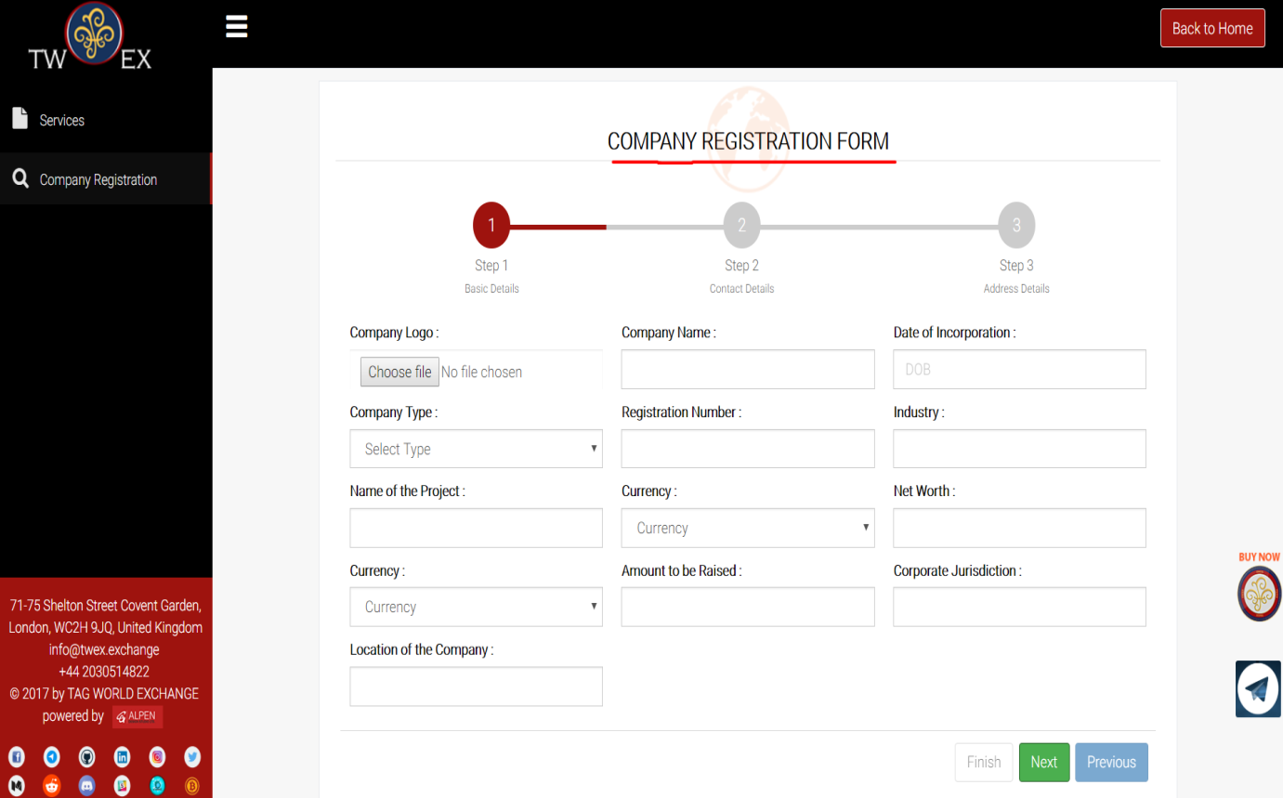

#### **STEP 2 – Contact Details**

In pre-ICO services **step 2** consists of the contact details of the company which requires the email-id, website, contact number and also another contact number (i.e. reference number) of the registrar or the companies getting registered.

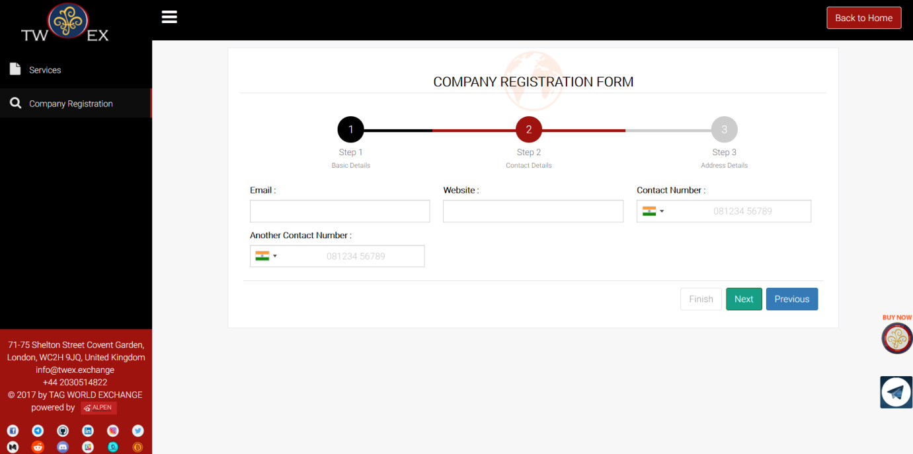

#### **STEP 3 – Address Details**

**3rd step** of Post-ICO services consists of address details of the registrar’s/ companies who have registered and as well as their correspondence address.

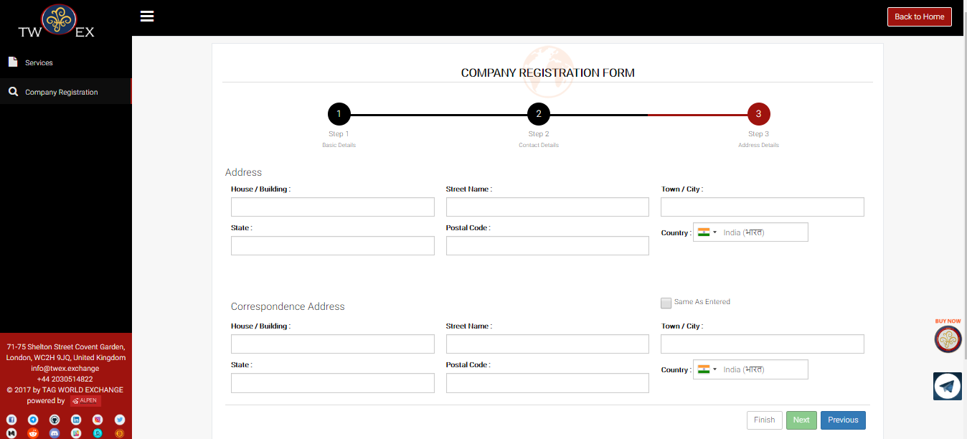

#### **STEP 4 – Confirmation**

After you have filled all your details click on finish button, you will get a Pop-up stating “**Are you sure want to proceed further?” then press OK button to proceed further**

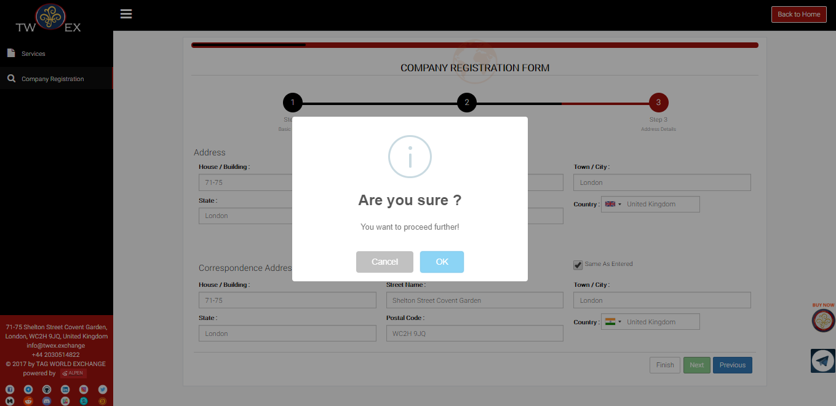

#### **STEP 5 – Completion**

After clicking OK, A message stating “Thank you for completing company registration” will appear which means that registration process for your company is completed. After registration, your request will be sent to legal and board for approval after which your company will be listed on TWEX Platform.



# TWEX Fund

This section contains all funding related details regarding TWEX Fund. TWEX fund has two options;

1. TWEX
2. TWAF

# TWEX

After clicking on TWEX Option, User will be redirected on the Home Screen.

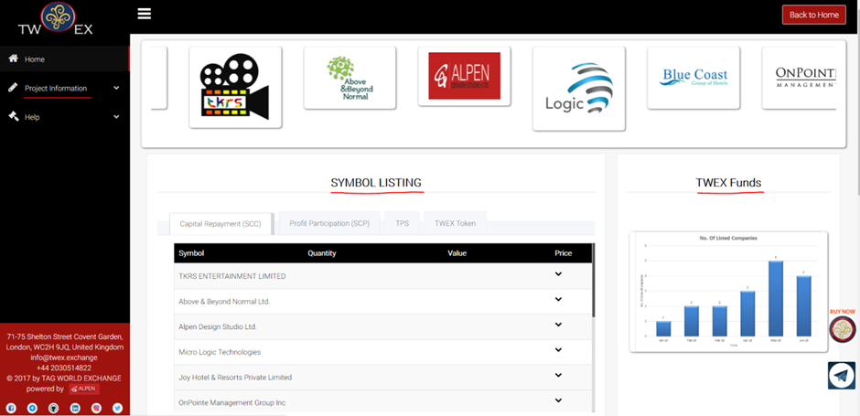

Home screen includes two following options:

* **Project Information**: Project Information includes information about projects, symbols and assets related to TWEX Platform.
* **Help**: Whereas under “HELP” you will find out documents and videos of TWEX Platform

**The Home screen is divided in following sections:**

1. Company listing
2. Symbol listing
3. TWEX funds
4. Events
5. News

## Company Listing

In this section you can find all the pictures representing projects listed on our platform. If you click on those pictures you will be redirected to a page with all details of the projects.

## Symbol Listing

In this section you can find all symbols listed on our platform.

Symbol listing includes 4 tabs for home screen

1. Capital Repayment (SCC)
2. Profit Participation (SCP)
3. TPS
4. TWEX Tokens

# Capital Repayment (SCC)

**Companies are listed on our Platform to raise funds. The funds raised by those companies needs to be repaid by them within a specific period of time which is represented in the form of symbols which is displayed in this section.**

There are several companies listed on TWEX Platform. For e.g. TKRS Entertainment Ltd has raised fund of 15,000,000 euros from TWEX, so the capital repayment done by TKRS will be divided into two parts i.e. 7,000,000 euros in 1s t 15 months and 8,000,000 euros in 2nd 15 months which is represented in the form of symbols i.e. **TKRS C1 and TKRS C2** accordingly.

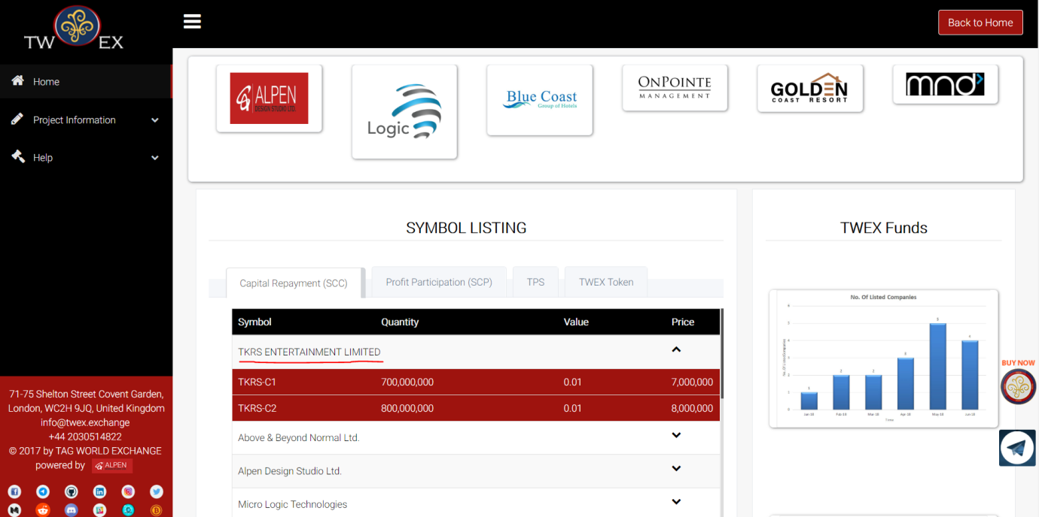

**Profit Participation (SCP)**

Capital repayment done by the companies has some value as profit which is determined in Profit Participation i.e. Represented in the form of symbols. You will find all symbols of Profit Participation in these section.

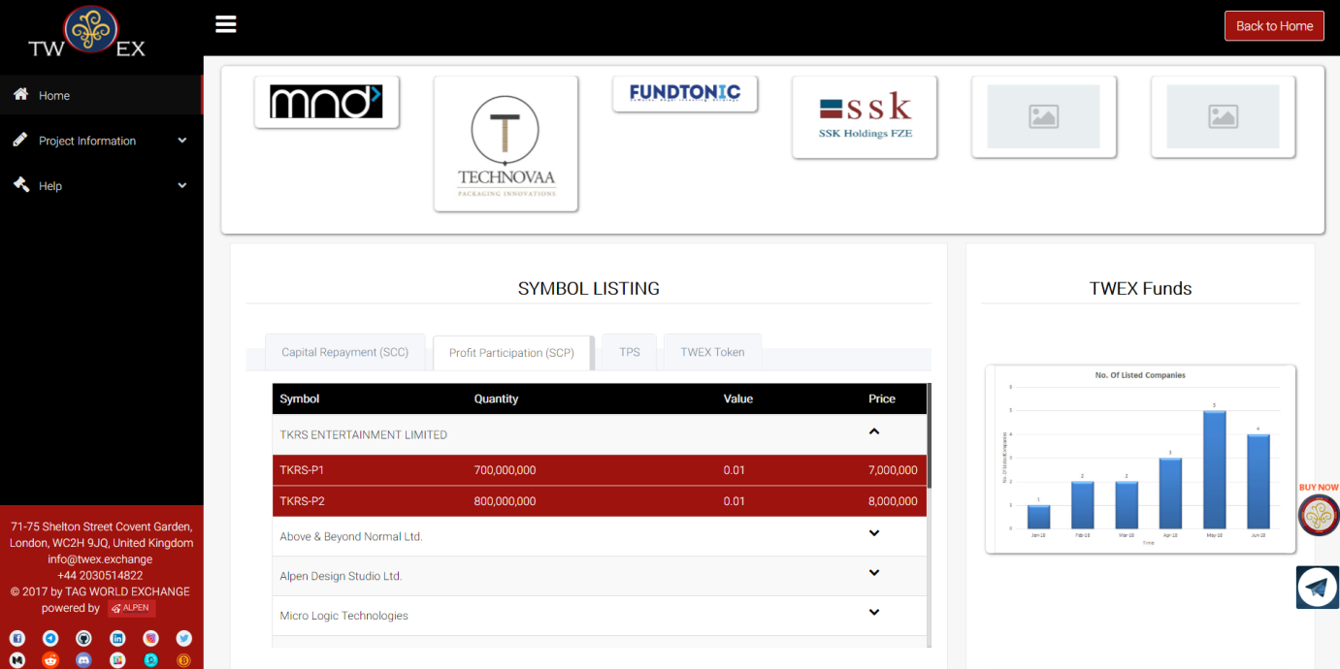

### **Tokenized Preferred Shares (TPS)**

### **TWEX Tokens**

## TWEX FUNDS

In this section you can find 2 graphs showing number of companies listed on TWEX Platform and second showing Asset Valuation annual projection.

When you click on the first graph you can see number of companies listed every month on TWEX Platform as shown in the image below.

|  |  |
| --- | --- |
|  |  |

**Asset Valuation:** When you click on the second graph you will see yearly Valuation of assets as shown in the following image

## Events

In event section you will get the information about the events organised by TWEX.

## News

In news section, you will get the latest updates about TWEX Platform.

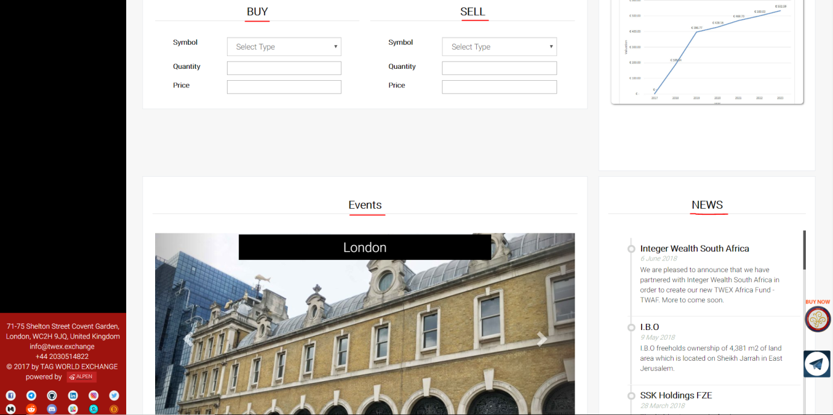

## PROJECT LISTING

On this page you will find all the projects listed on our TWEX Platform. To visit project listing page you need to click on project information menu present on the left side of the user menu after which you can find 3 options i.e. project listing, symbols and values and asset valuation. Click on project listing option after which you will be redirected to the project listing page where you can find the following categories.

1. TWEX Portfolio
2. Current ICO
3. TWAF Portfolio

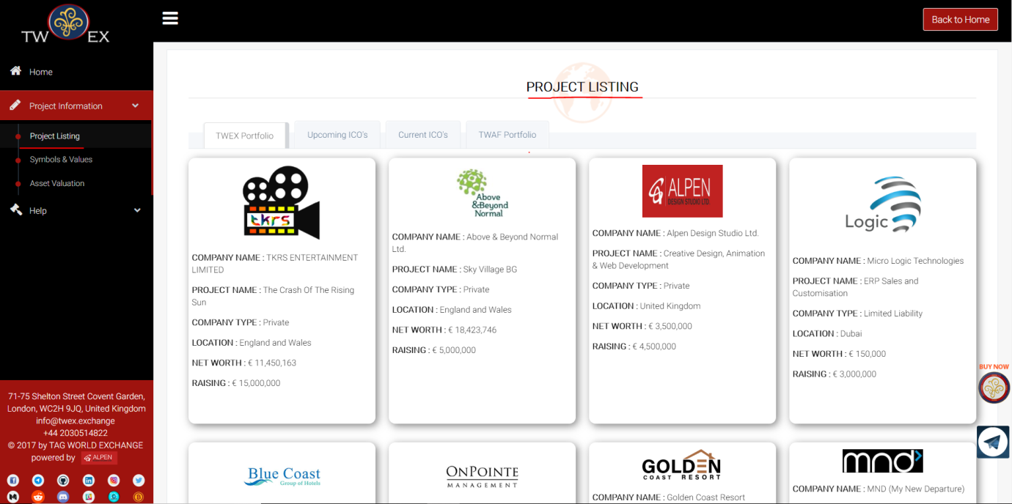

### TWEX Portfolio

In this category you will find portfolios of all companies listed on the platform in grid manner. On each project you can find the information about the company name, Project name, Company type, Location, Net worth, Raising If you put your mouse cursor on that project it will flip with a button of label “know more”.

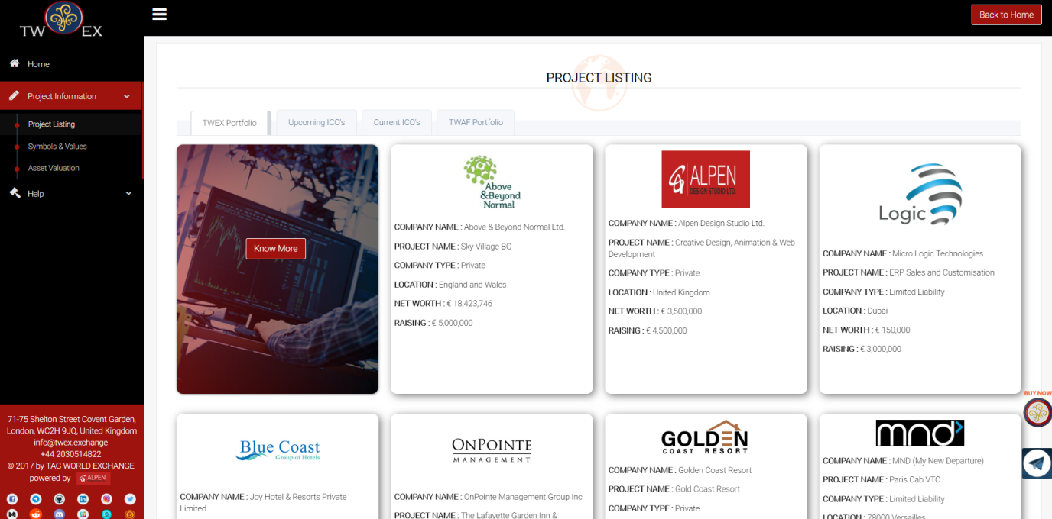

When you click on “know more” button, you will be redirected to a page with all details available related to that project.

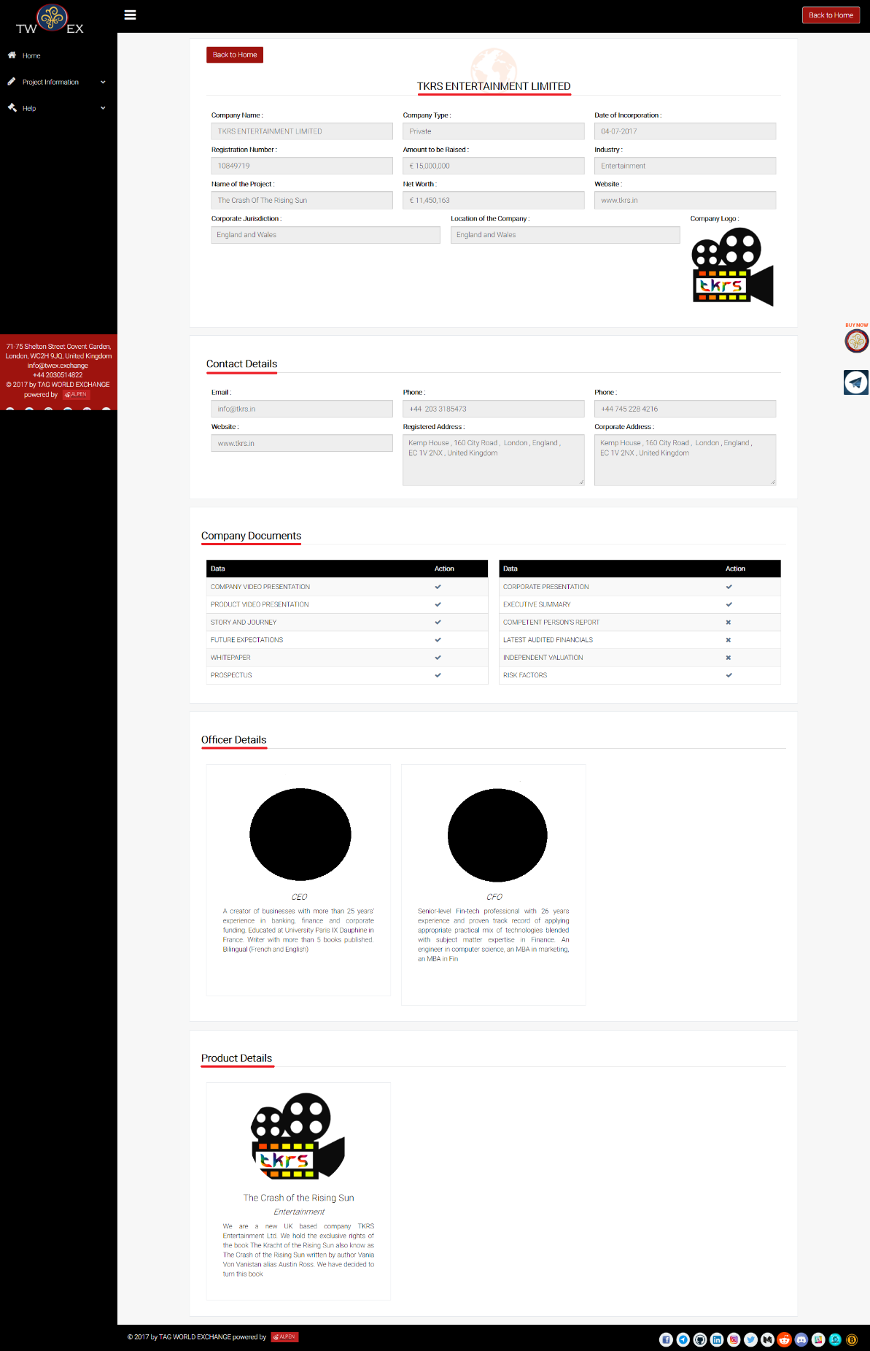

Example: **TKRS Entertainment**

This page shows details of the project listed in following sections:

* Basic details
* Contact details
* Company documents
* Officer details
* Product details

Basic details show the following fields:

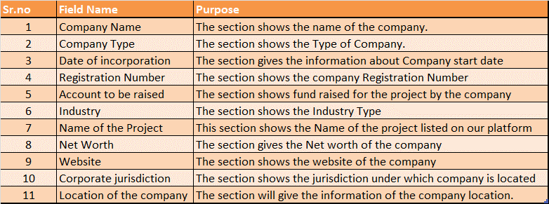

### Upcoming ICO’s

Here you can find projects listed from Pre-ICO module. If you want to view projects listed from upcoming ICOs Please click on the 2nd tab of this page which has label upcoming ICOs. After clicking on the 2nd tab the view will be as shown below.

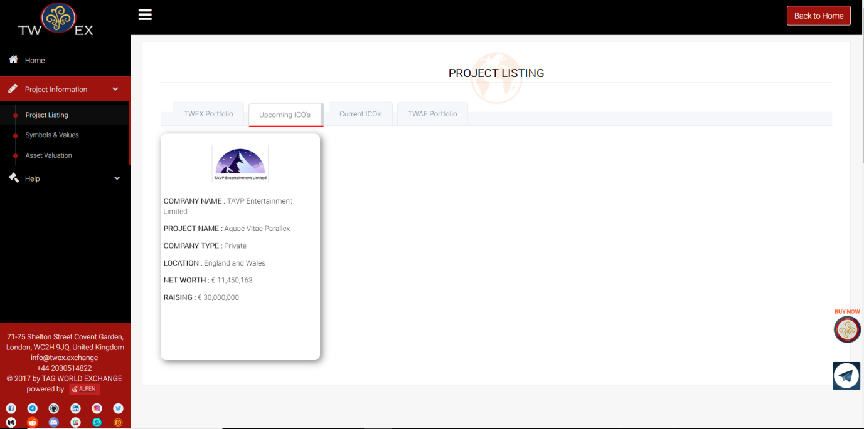

### Current ICO’s

Here you can find projects listed from Post-ICO module. If you want to view projects listed from current ICOs Please click on the 3rd tab of this page which has label current ICOs.

### TWAF Portfolio

Here you can find projects listed from TWAF module. If you want to view projects listed from TWAF Portfolio. Please click on the 4th tab of this page which has label TWAF Portfolio.

## Symbols and Values

In this section you can find all symbols listed currently on our Platform. This symbols are Smart Contracts which shows Capital Repayment and Profit Participation of each company. To visit this page click on the project information menu provided in the user menu under which you can find symbols and values option clicking on which you will be re-directed to this page which will be as shown below.

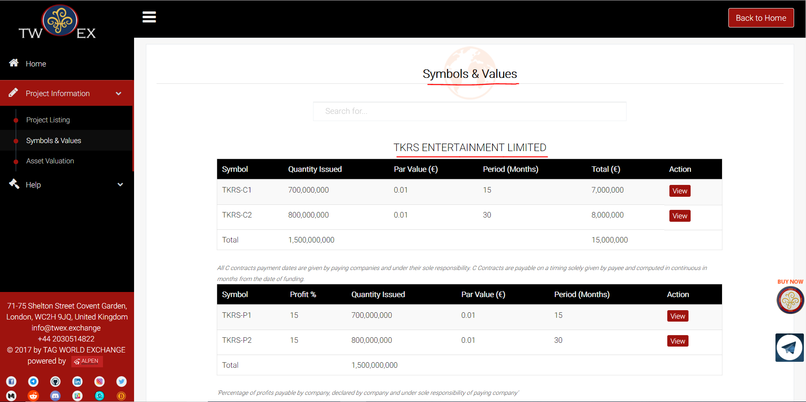

In the above screen you can see Symbols of one of our listed company TKRS ENTERTAINMENT LIMITED. Under which you can see 2 tables below:

1. Capital Repayment
2. Profit Participation

### Capital Repayment

Capital Repayment table shows symbols that represents capital repayment done within a given period. For e.g. in case of TKRS you can see symbol TKRS-C1 - will repay 700,000,000 euro in 15 months whereas symbol TKRS-C2- Will repay 800,000,000 euro in 30 months.

### Profit Participation

In this section you can find, Profit participation Contract of listed companies represented in the form of symbols. For e.g. In case of TKRS Entertainment Ltd, symbol TKRS P1 – Capital value will be 700,000,000 euro and profit will be 15%, whereas symbol TKRS P2 – Capital value will be 800,000,000 euro and profit will be 15%.

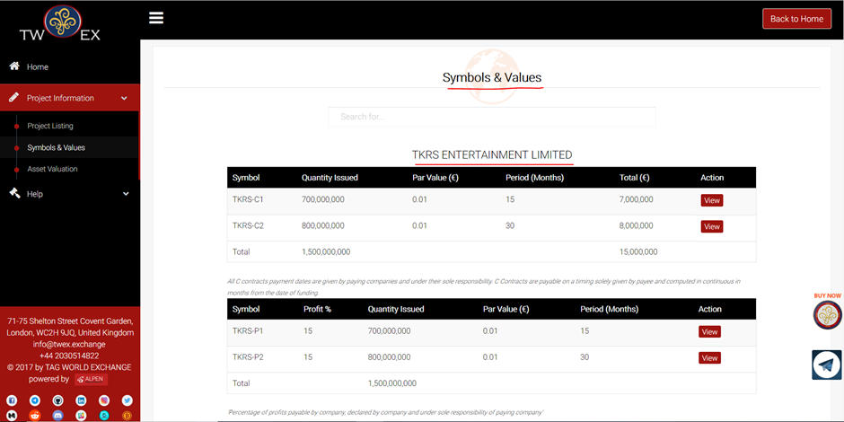

## Asset Valuation

In this section you will find the list showing funds raised by the companies listed for projects on our Platform, the value of their current assets and the value for the upcoming 5years. This page is placed under **“project information”** menu of the **USER MENU** provided on the left side, the layout of which is as shown below.

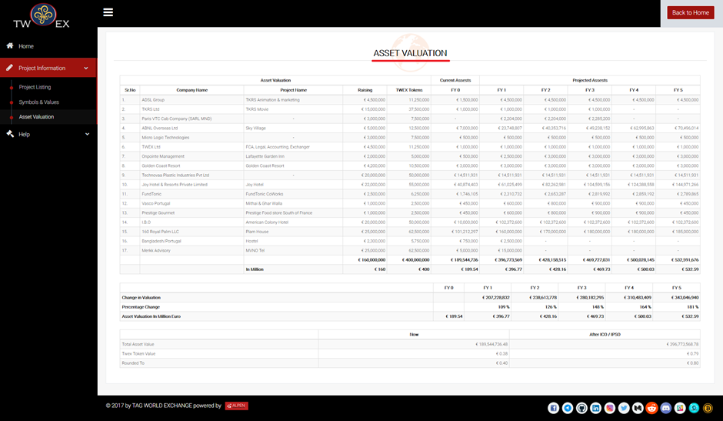

In the above screen you can find following columns from the table provided.

* **Company name** – Includes the projects name which are listed on our Platform.’
* **Projects-** It includes the funds raised by the companies for their projects.
* **TWEX Tokens:** Number of TWEX tokens issued based on the funds raised by the companies for the projects.
* **Raising:** Funds raised by the companies for the projects
* **Current Financial Year:** This section shows the current asset value of the companies.
* **Projected Financial Years:** This section shows the asset value for the upcoming 5 years.

# **TWAF**

TWAF stands for TWEX Africa. TWAF is a fund designed to help raise funds and promote African companies and businesses while giving access to profitable investments to International investors.

If you want to list on TWAF Platform, click on TWAF Tab, by clicking on TWAF tab it will redirect you to TWAF homepage.

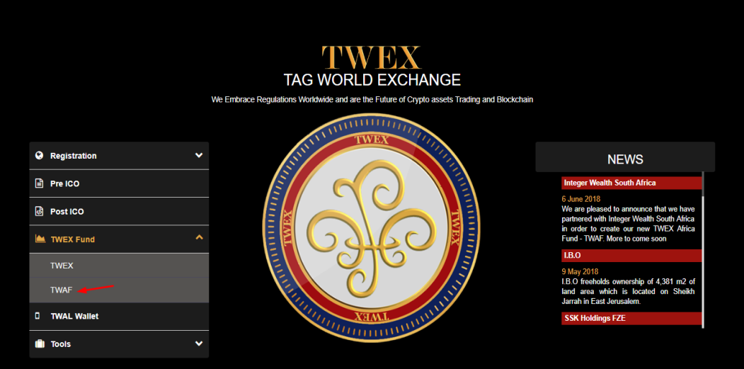

## Home

In homepage you can see content stating partnership of TWEX and Integer Wealth Value as mentioned earlier. And you can see updates related to TWAF Token and TPS along with their lot of smart contracts.

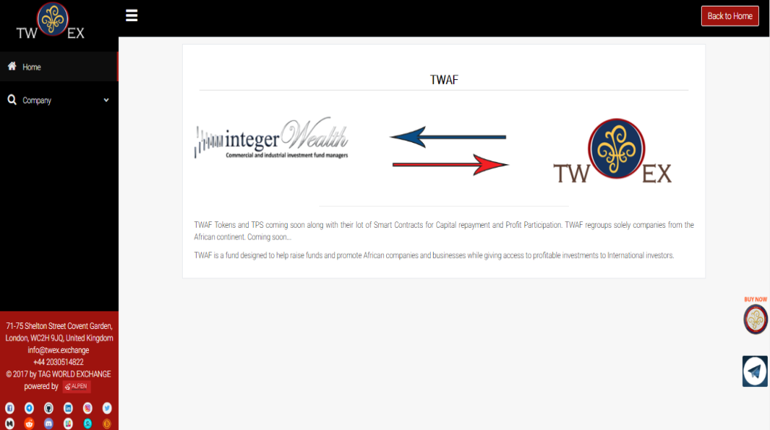

## Company

### How to get listed

If you want to list on TWAF Platform, go to company and select how to get listed. After clicking on how to get listed a page will appear which includes all terms and conditions and details regarding documents to be uploaded by an applicant. Please go through all the points present on this page.

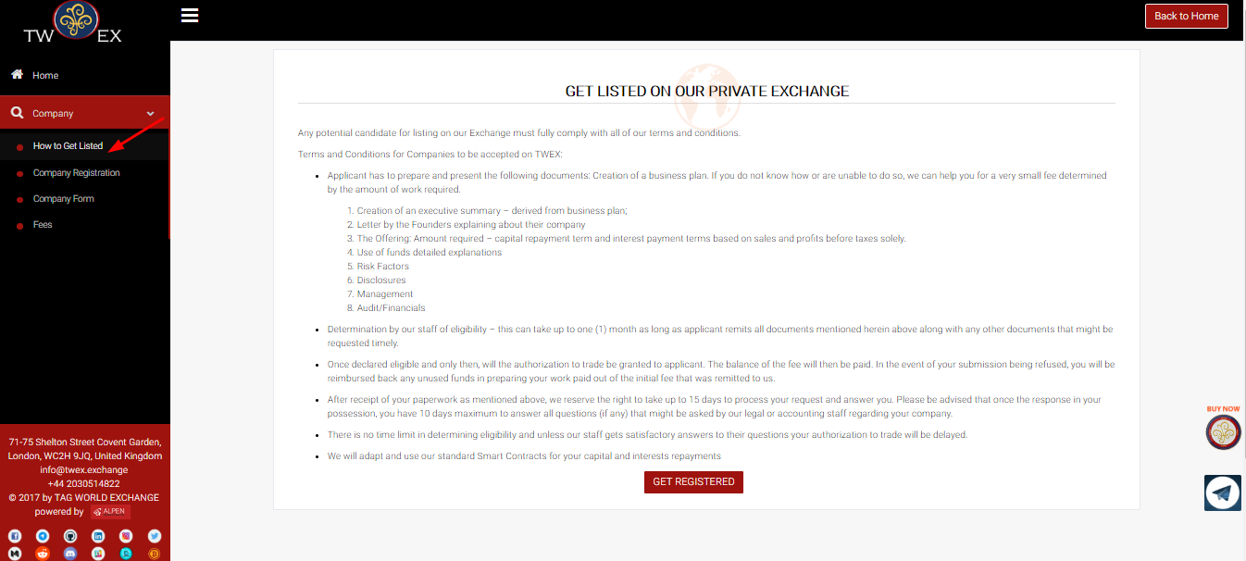

### Company Registration

If you want to get registered on TWAF platform you can directly click on company registration or click on get registered which is present on “How to Get Listed” page following details. On the “How to Get Listed page”, you can find all information regarding company registration.

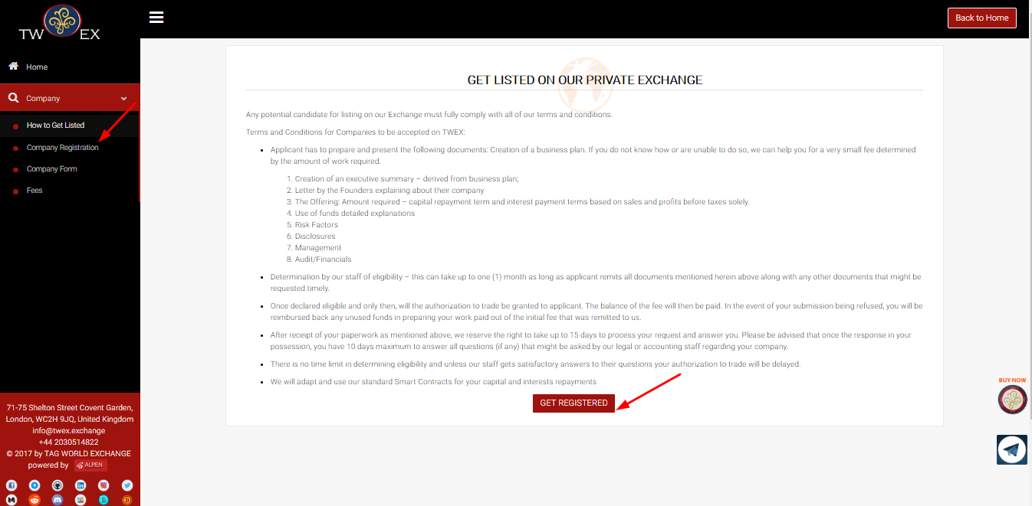

1. After clicking on get registered It will redirect you to the following page it shows that you have to upload certain documents which includes videos of company presentation, their story and their journey, and future expectation. To get registered click on Register now button.

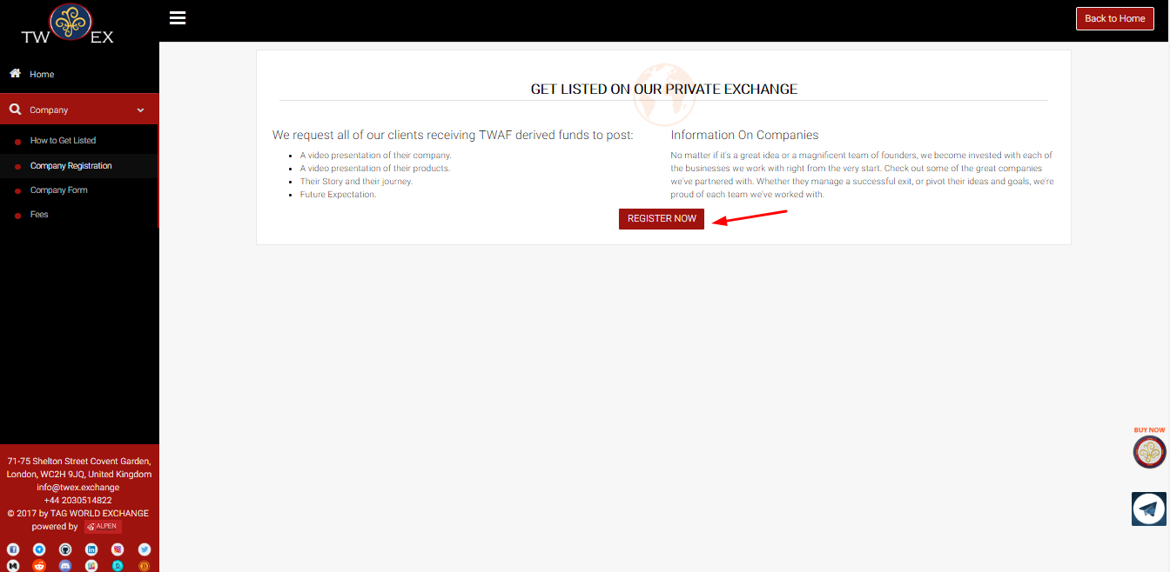

1. After clicking on register now, you will be redirected to company registration form page. In company registration form you can find 3 steps
   1. Basic Details
   2. Contact Details
   3. Address Details

#### **STEP 1 – Basic Details**

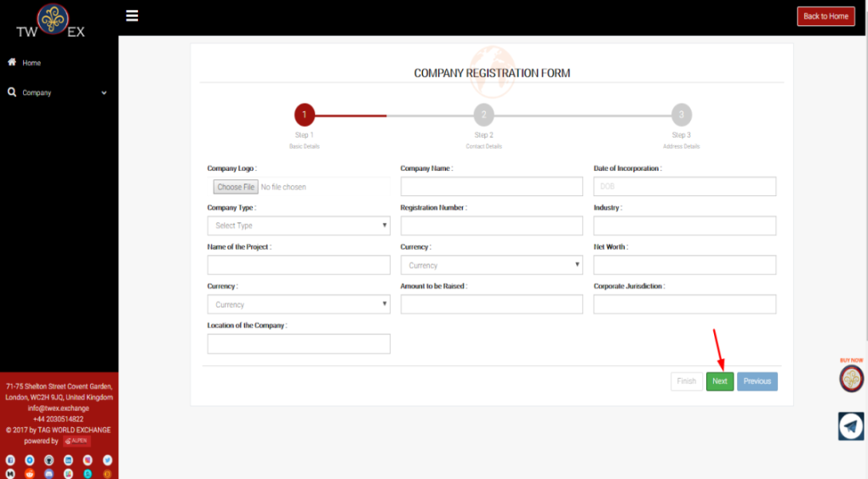

**The form above has the following fields to be entered**

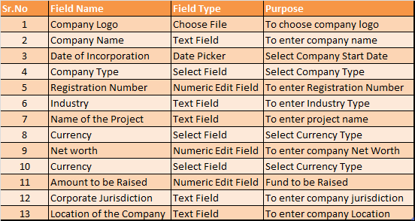

Please fill all details and click on next button. By clicking on next button it will redirect you on the step 2 of company registration form.

#### **STEP 2 – Contact Details**

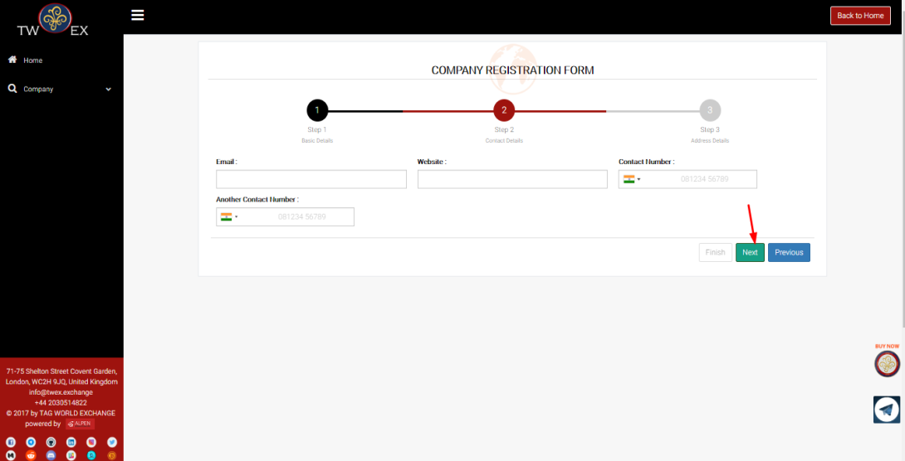

**The form above has the following fields to be entered**

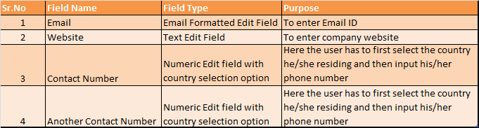

By clicking on next button it will redirect you on the step 3

#### **STEP 3 – Address Details**

Note - If your correspondence address is as same as above then click on the same as entered. And after filling your all details click on finish button.

.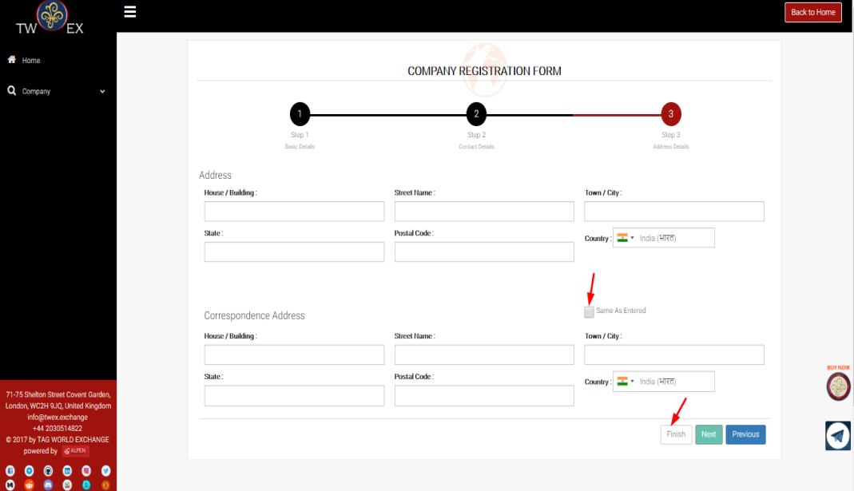

**The form above has the following fields to be entered**

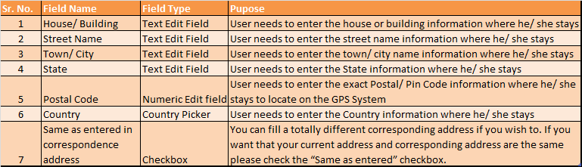

After clicking on finish the message page will appear asking are you sure want to proceed further, if you want then click on OK button

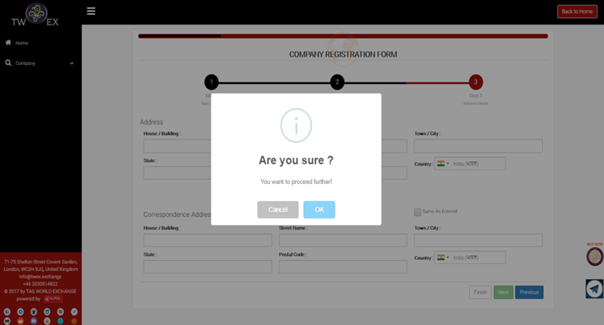

After clicking on OK button registration process will be completed and then a message will appear stating that **“Thank you for completing company Registration”** on the screen which shows that the initial process of registration is complete. And it will redirect you on company Form

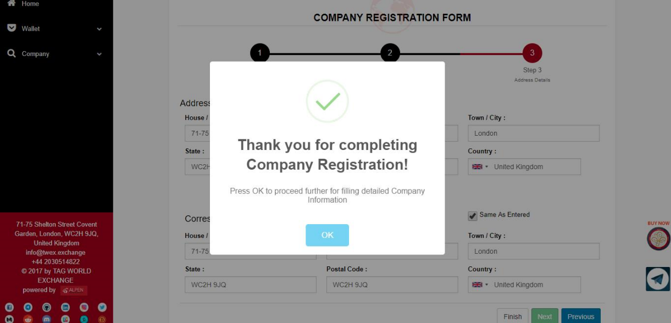

### Company Form

After completing the initial registration process you will be redirected to the second form which includes input fields for files upload. The form below has following four sections.

1. Videos
2. Information
3. Story and future
4. Company Documentation

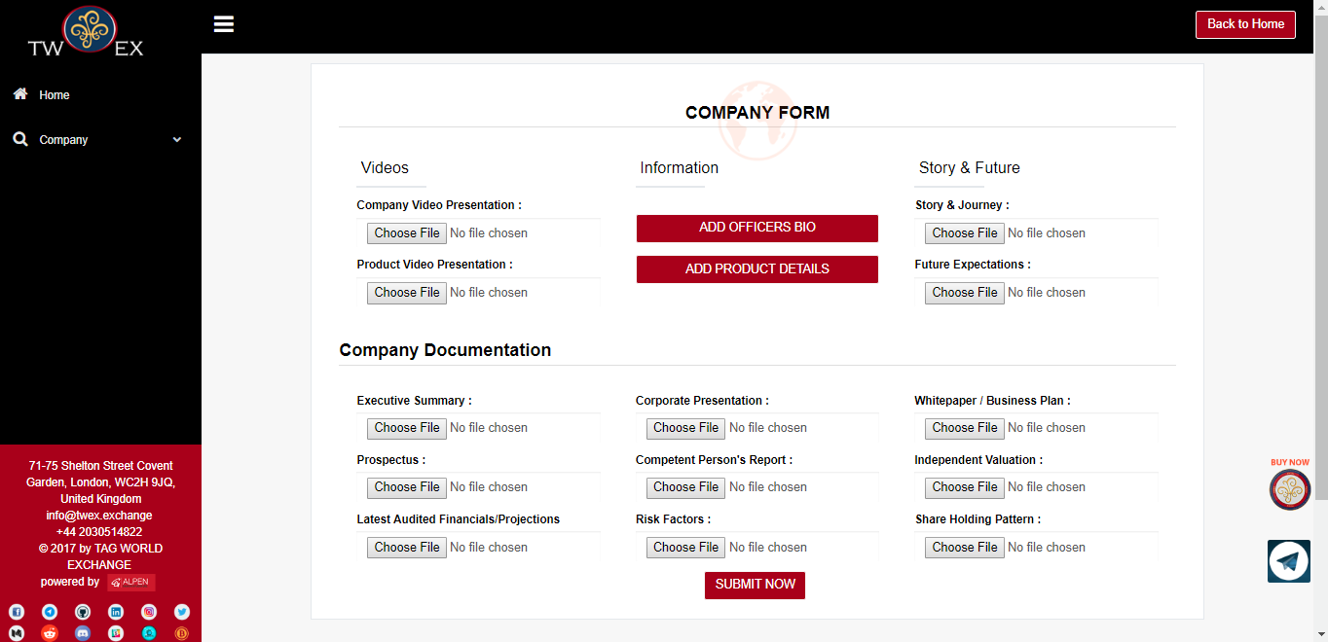

#### Videos

In videos section following fields are provided to upload company video presentation and product video presentation respectively

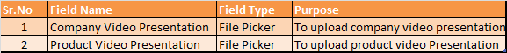

#### Information

There are two buttons with labels;

1. Add Officers Bio
2. Add Product Details

Add officers Bio button is provided to add officer details of your organization when you click on this button a form will appear which is as shown below.

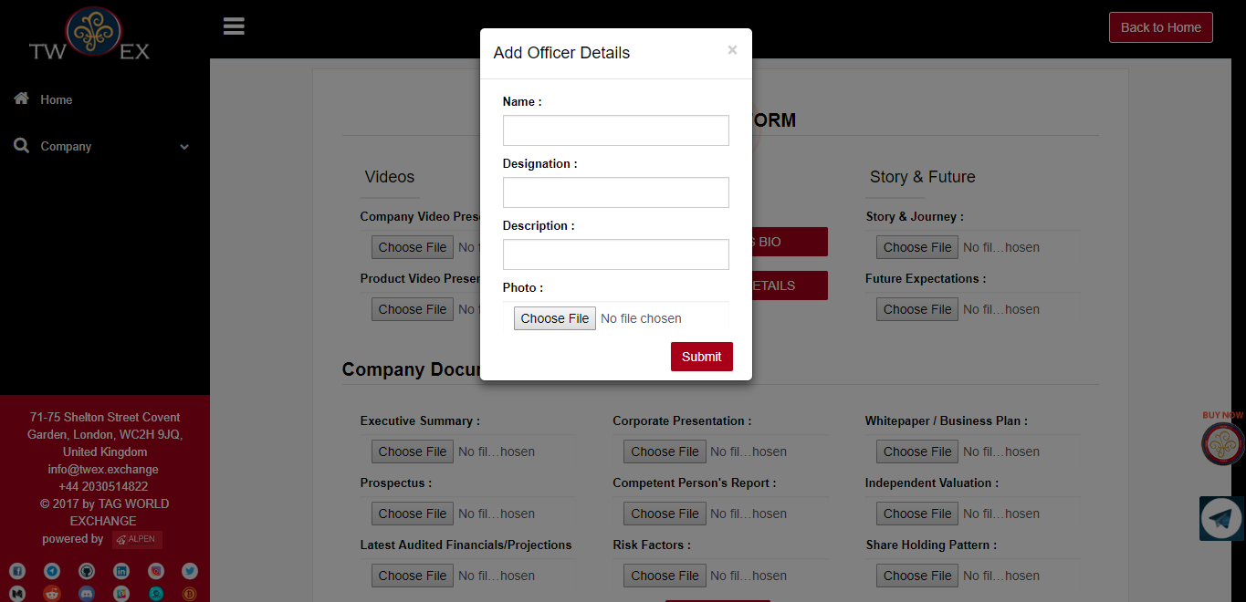

**The form above has the following fields to be entered**

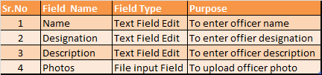

After filling all the above details click on the submit button. After which officer details will be added.

Add product Details button is provided to add product details of your organization when you click on this button a form will appear which is as shown below.

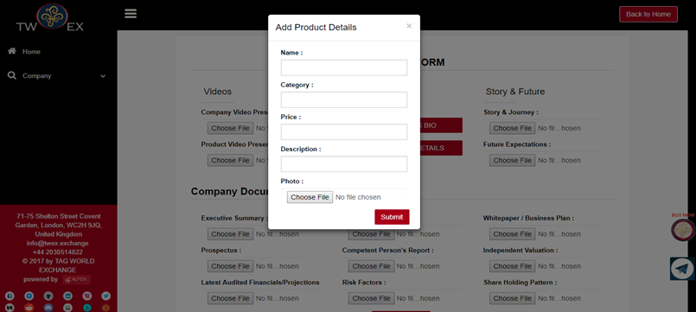

**The form above has the following fields to be entered**

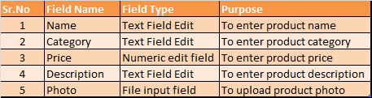

After filling all the above details click on the submit button. After which product details will be added.

1. **Story And Future**

This section is provided to upload documents related to story and journey and future expectations of your company. Following are the fields provided for the same.

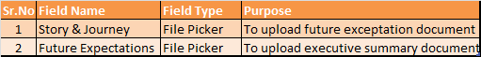

1. **Company Documentation**

This section is provided to upload all the documents required to list your company on TWAF platform, following are the fields provided for the same.

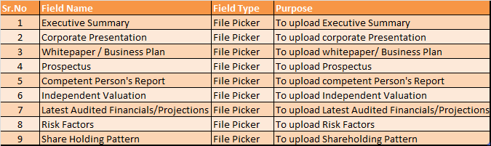

After clicking on submit button, all your provided documents will be uploaded and you will be redirected to the final company form appear which has 5 steps,

1. Basic Details
2. Company Details
3. Financial Details
4. Legal Details
5. Marketing Details

#### **STEP 1 – Basic Details**

Step 1 in this page, all your updated details in your initial form will appear, Please go through all information provided in read only fields. After that click on next it will redirect you on step 2

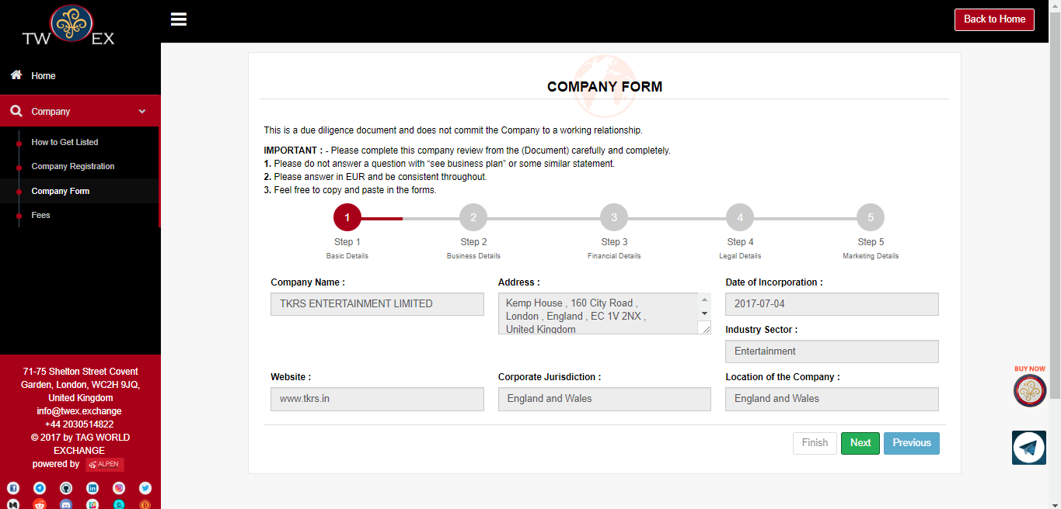

**The step above has the following fields to be checked**

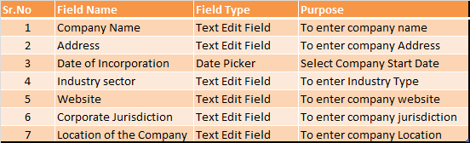

#### **STEP 2 – Company Details**

Step 2 in this page you have to fill all business related details. Please go through all fields provided

. 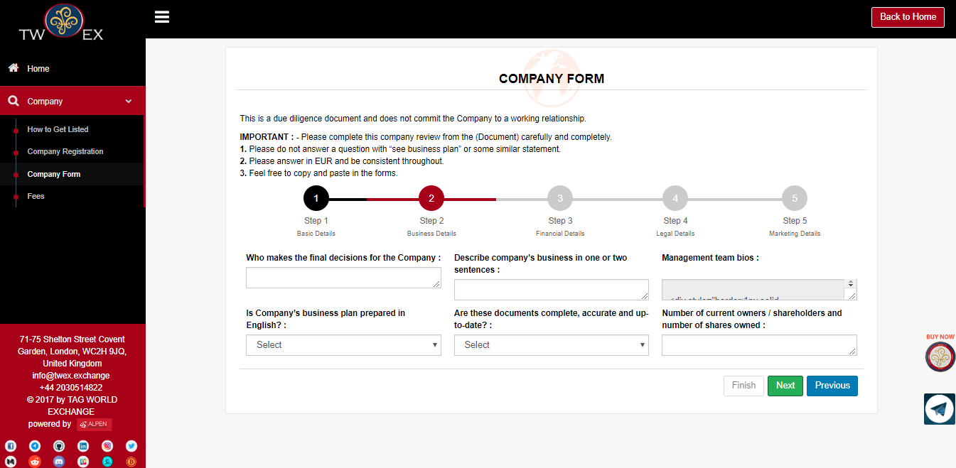

**The step above has the following fields to be entered**

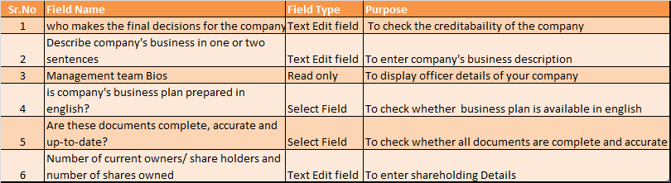

After that click on next button it will redirect you on step 3,

#### **STEP 3 – Financial Details**

Step 3 of this form has all finance related details. Please go through all fields provided.

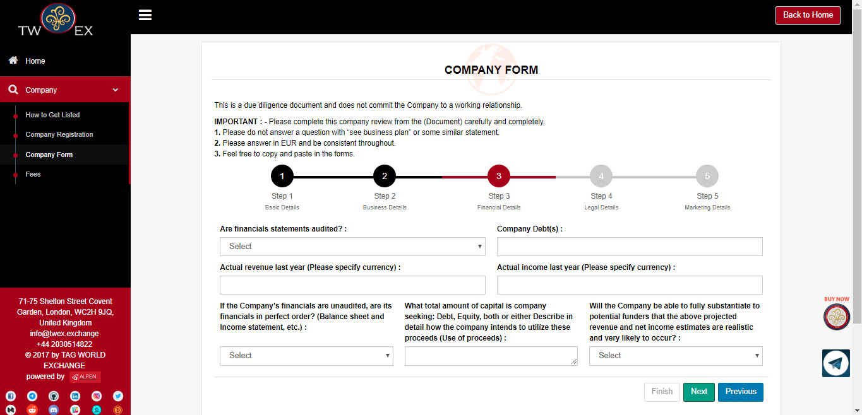

**The step above has the following fields to be entered**

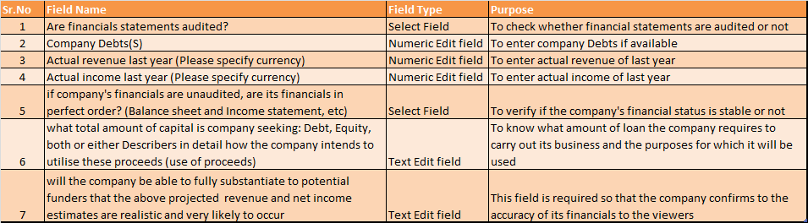

After that click on next button it will redirect you on step 4,

#### **STEP 4 – Legal Details**

Step 4 of this form has all legal details. Please go through all fields provided.

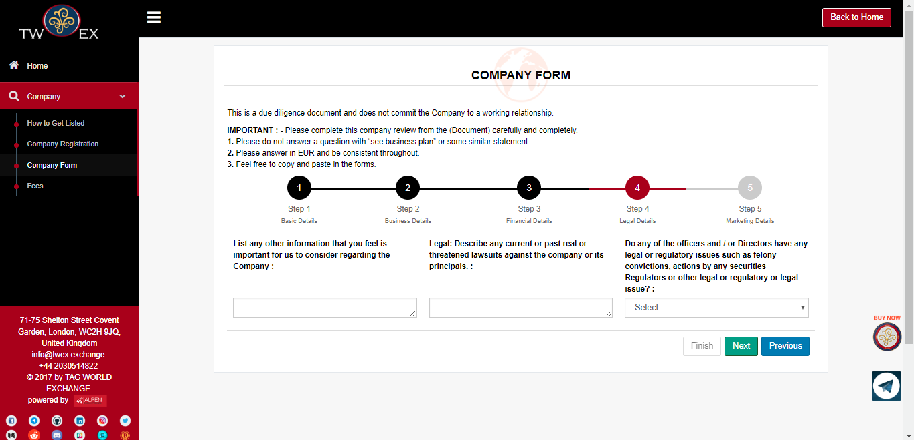

**The step above has the following fields to be entered**

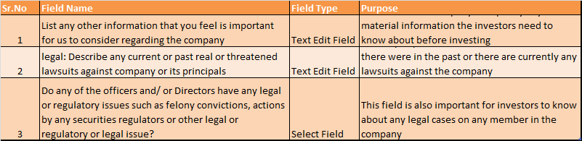

After that click on next button it will redirect you on step 5.

#### **STEP 5 – Marketing Details**

Step 5 of this form is the last step which includes all marketing related fields. Please go through all important points.

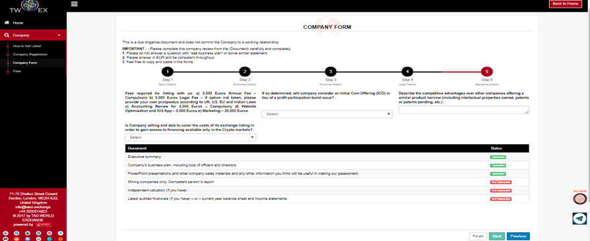

After filling all the fields, Click on **Finish** button.

**The form above has the following fields to be entered**

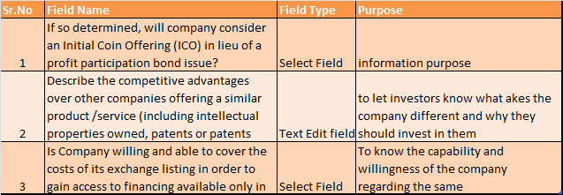

After clicking on finish button a message will appear on screen stating that Are you sure want to proceed further, if yes then click on OK button to proceed further.

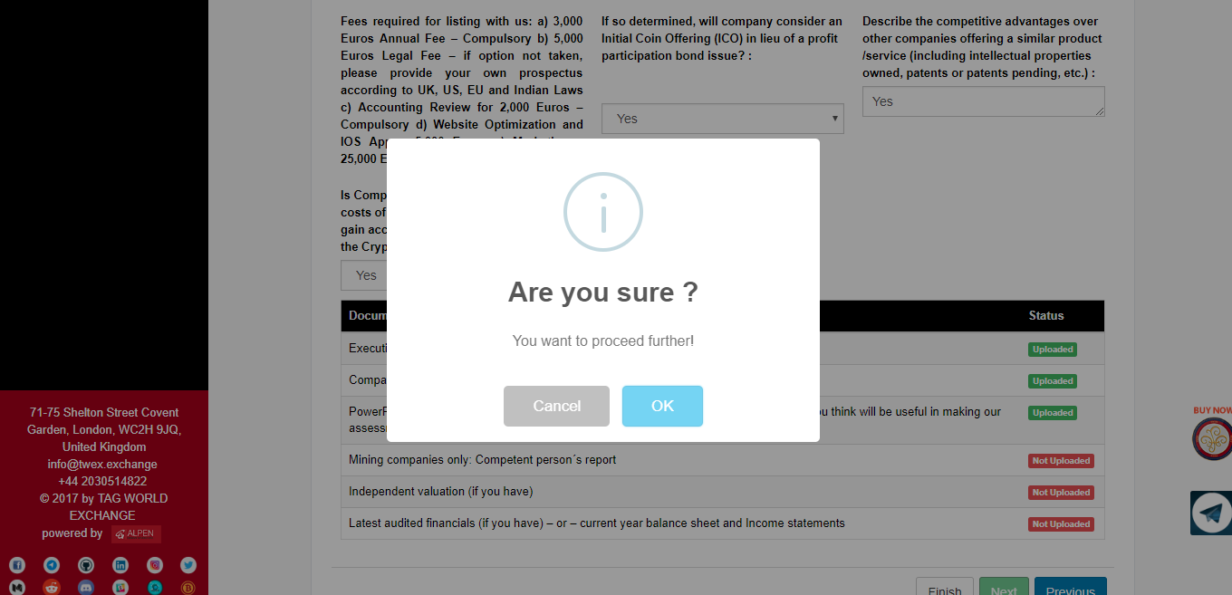

After clicking on OK button a new message will appear stating that “Thank you for filling company information” which means your registration process is completed. Click on OK button.

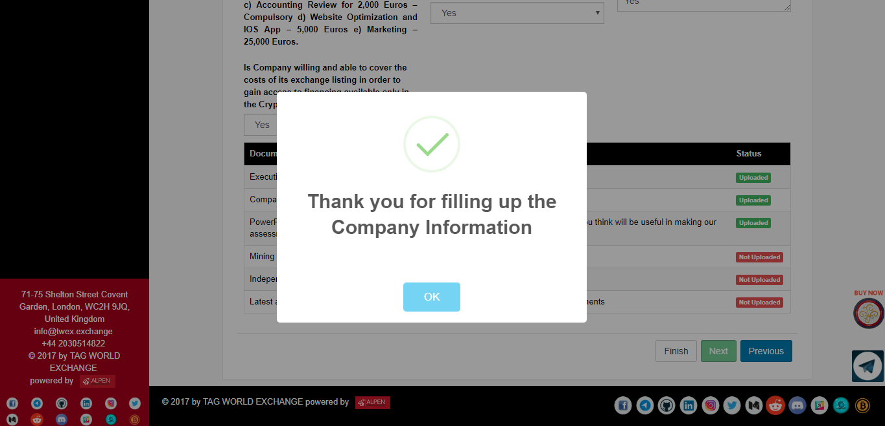

### Listing Fees

After completing all the procedures of filling company information, A page with pricing details will appear, there are five different pricing options,

1. Annual listing pricing
2. Prospectus and legal fee
3. Accounting
4. App development plus website
5. Marketing

An annual listing pricing and accounting are compulsory options remaining three options are optional. After selecting all pricing options as per your choice, calculated total amount will be displayed below.

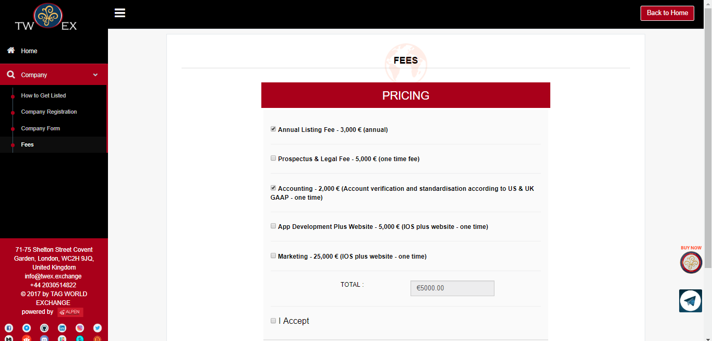

Then click on I Accept checkbox. After clicking on I Accept checkbox, a new button will appear with label “**Purchase Now**” as shown on the below screen.

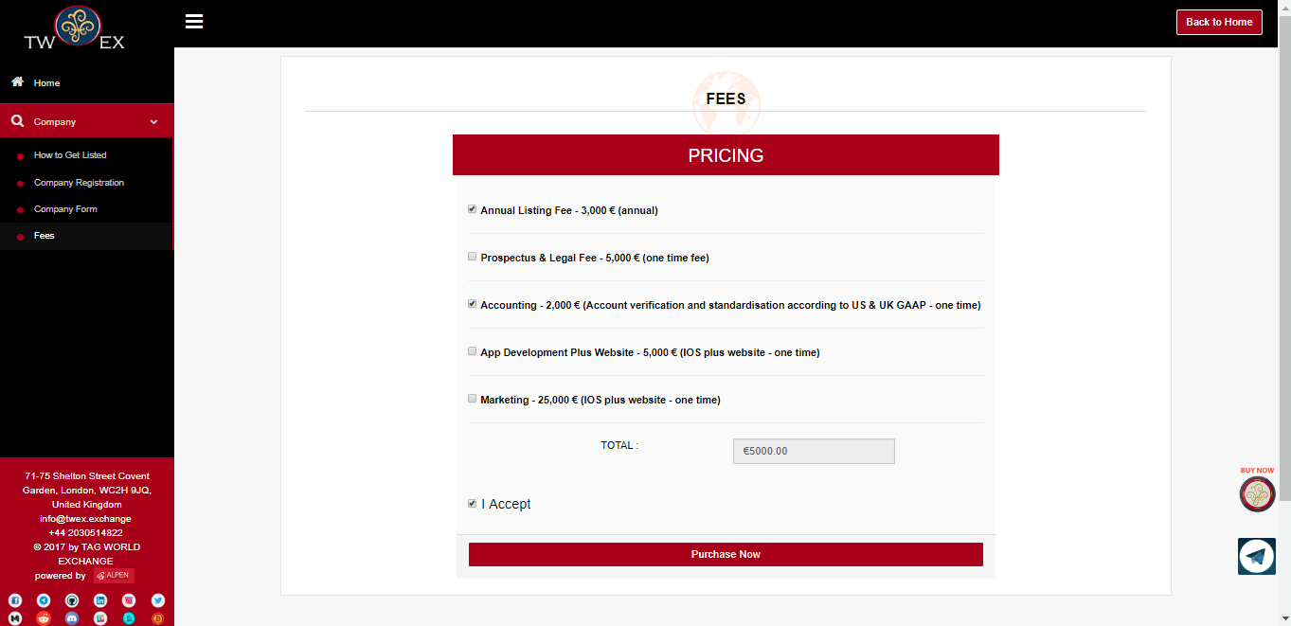

Please click on purchase now button. After purchasing a message will appear stating that **“Thank you for filling company information”** which means thatyour all process of registration is complete**.**

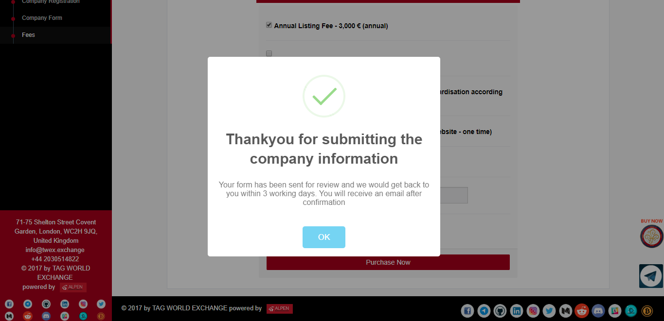

After completing all the process of company registration your details will be sent for review by our legal and board department. You will receive an Email after confirmation from both the legal and board approval.

# **TWEX Hardware Wallet (TWAL)**

***“World’s first innovative hardware wallet solution with focus on latest biometric security technology”***

#### **Introduction**

A hardware wallet is a special type of [e-wallet](https://en.bitcoin.it/wiki/Wallet) which stores the user's private keys in a secure hardware device.

They have major advantages over standard software wallets:

* Private keys are often stored in a protected area of a microcontroller, and cannot be transferred out of the device in plaintext.
* Immune to computer viruses that steal from software wallets.
* Can be used securely and interactively, private keys never need to touch potentially-vulnerable software.
* Much of the time, the software is open source, allowing a user to validate the entire operation of the device.

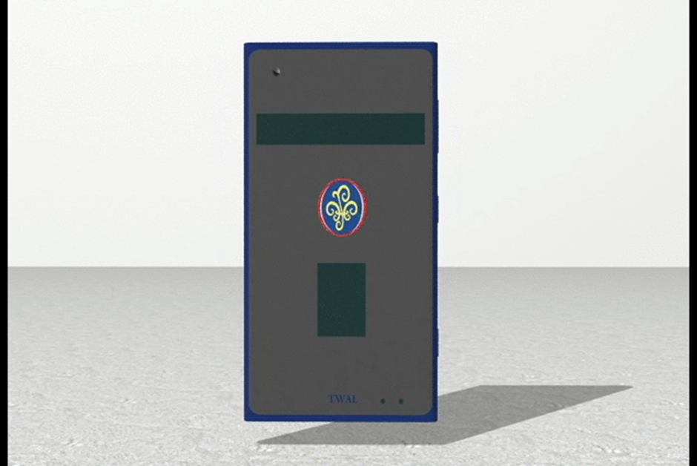

#### **About TWAL**

TWEX wallet is the world’s first innovative hardware wallet solution with focus on latest biometric security technology.  TWEX Hardware Wallet (TWAL) The TWEX hardware wallet is a solution which will identify the user in the secure way of having dual verification process of facial reorganization and finger print reorganization and indicate the same via Bluetooth. The proposed device is a security device to identify the user for enabling them to use the mobile wallet/ any other secure transaction. The device includes the following, Fingerprint sensor, Camera Interface for the face recognition, verification etc.

To know more about TWEX Hardware wallet you can click on the following link.

<https://s3.ap-south-1.amazonaws.com/twexfiles/videos/marketing/TWEX+Hardware+Wallet.mp4>

#### **Features of TWAL**

The TWEX hardware wallet is a solution which will identify the user in the secure way of having dual verification process of facial reorganization and finger print reorganization and indicate the same via Bluetooth

The proposed device is a security device to identify the user for enabling them to use the mobile wallet/ any other secure transaction. The device includes the following,

1. Fingerprint sensor
2. Camera Interface for the face reorganization, verification & authentication
3. BT for communicating with the phone
4. LCD interface on the device for the status indication
5. USB interface to connect to PC and record the fingerprint and face reference , battery
6. Charging ( back up of the battery we can specify)
7. All the authentication should be done on the device
8. The device will verify the finger recognize the fingers first and then the face.
9. Once both the reorganization is completed, it will need to send the unique ID to the phone
10. An App, which will be authenticated for the wallet operation.

|  |  |
| --- | --- |
|  |  |
| 3 Types of Proposed Color Version | Blue Color Version |
|  |  |
| White Color Version | Golden Color Version |

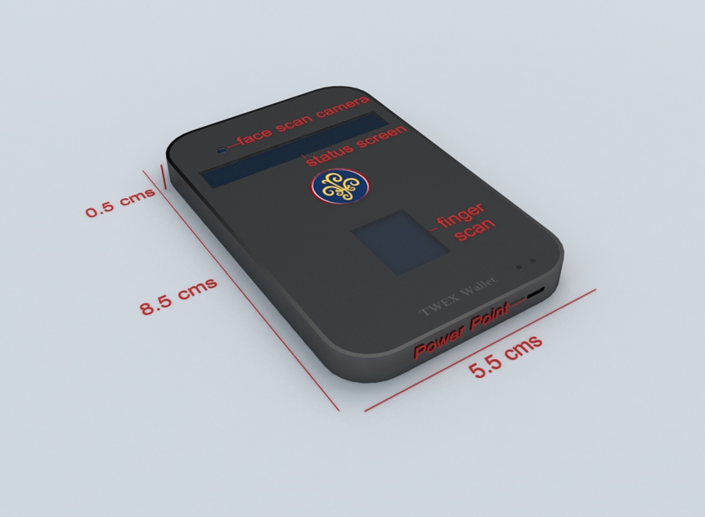

#### **Investment**

Tag World Exchange is seeking funds to the tune of 350,000 Euro to build the worlds' first innovative hardware wallet solution that would focus on the latest security bio-metric technology.

It is based on cognitive algorithm that couple facial recognition, thumbprint recognition and cryptography. Moreover, a smart card will be implemented to store private keys and prevent any theft of customer’s data keys.

#### **Listing**

TWAL product has been listed on the following fund raising platform

<https://www.indiegogo.com/projects/twex-hardware-wallet--2#/backers>

#### **TWAL Early Bird**

For a unit sale price of 90 Euro, the early bird is eligible for discount of 30 Euro. This discount is available for first 5000 units.

# **CONCLUSION**

TWEX Platform is a complete system where stakeholders can list their projects in the pre-ICO stage and move it to the ICO stage to raise capital from the market. Its uniqueness in terms of Tokenized Preferred Shares (TPS) model and its structure of Capital Repayment and Profit Participation makes it an attractive instrument for investors who seek to protect their investments as well as reap out the benefits to invest in projects.